

JUNE 2016

This document was produced for review by the United States Agency for International Development. It was prepared by Cloudburst Consulting Group, Inc. for the Evaluation, Research, and Communication (ERC) Task Order under the Strengthening Tenure and Resource Rights (STARR) IQC.

Mobile Application To secure Tenure Pilot Project (MAST)

User Manual for the Mobile Application (Version 3.0)

Prepared for the United States Agency for International Development, USAID Contract Number AID-OAA-TO-13-00019, Evaluation, Research and Communication (ERC) Task Order under Strengthening Tenure and Resource Rights (STARR) IQC No. AID-OAA-I-12-00030.

Implemented by:

Cloudburst Consulting Group, Inc.

8400 Corporate Drive, Suite 550

Landover, MD 20785-2238

Mobile Application to Secure Tenure Pilot Project (MAST)

User Manual for the Mobile Application

Version 3.0

JUNE 2016

**DISCLAIMER**

The authors' views expressed in this publication do not necessarily reflect the views of the United States Agency for International Development or the United States Government.

taBLE OF CONTENTS

1. Document Overview 5

2. About THE MAST Application 5

3. Installation Steps 6

4. Login 6

5. Map Viewer 9

5.1 Layer Manager 11

5.2 GPS 13

5.3 Get location co-ordinates 14

5.4 Measure 16

5.4.1 Calculate Distance 17

5.4.2 Calculate Area 18

5.4.3 Measure Polygon Area 19

5.4.4 Measure Line Length 20

5.5 map Info Tool 21

5.6 Add/View Bookmark 22

5.6.1 Add Bookmark 23

5.6.2 View Bookmark 24

6. Download Data 25

7. Verify Data 27

7.1 Pending 28

7.1.1 View Map 29

7.1.2 View Attributes 31

7.1.3 Mark as Verified 32

7.2 Verified 33

7.3 Final 34

8. Capture Data 35

8.1 Layer Manager 37

8.2 Zoom to Current Location 38

8.3 Add Bookmark 39

8.4 View Bookmark 40

8.5 Add Feature 41

8.5.1 Capture Point 42

8.5.1.1 Draw Point 43

8.5.1.2 Enter Location 44

8.5.2 Capture Line 46

8.5.2.1 Draw Line 47

8.5.2.2 Capture Line by GPS 48

8.5.3 Capture Polygon 49

8.5.3.1 Draw Polygon 49

8.5.3.2 Capture Polygon by GPS 51

8.6 Capture Attribute 52

8.7 Edit Spatial 66

8.9 Delete Feature 70

8.10 Measure 72

8.10.1 Calculate Distance 73

8.10.2 Calculate Area 74

8.10.3 Measure Polygon Area 75

8.10.4 Measure Line Length 76

8.11 Map Info Tool 77

9. Review Data 78

9.1 Draft List 79

9.1.1 Edit Spatial 80

9.1.2 Edit Attribute 81

9.1.3 Delete Entry 84

9.1.4 Mark as complete 85

10. Download Data 87

11. Synchronize Data 88

12. User Preferences 89

12.1 Change Language 90

12.2 Configure Data Collection Tool 91

12.3 Configure Auto Sync 92

12.4 Configure Map Display 92

12.4.1 Point 93

12.4.2 Line 94

12.4.3 Polygon 95

13. Logout 96

1. Document Overview

This document provides guidelines for users (Trusted Intermediaries and Adjudicators) of the MAST Mobile Application.

This mobile data capture application has been designed to work on Android based hand-held devices only and enables the field users to capture data of parcels (spatial units) in the field along with parcel attributes and multimedia information.

Pre-requisite:

1. Android application (apk) file should be installed on the device.
2. Internet connectivity should be available to download the data before initiation of data capturing work.
3. About THE MAST Application

The key objective of MAST is to provide a framework for capturing land rights information using a participatory approach. This framework provides a suite of applications to support the collection and management of land rights information with following key components:

**Mobile Data Capture Application** – The mobile data capture application is an Android-based mobile application to capture land rights information (spatial, alphanumeric and multimedia) on mobile devices in field.

The mobile application is able to conduct data collection work without being connected to a central cloud-based server in offline mode. Data will be collected and stored on users’ handheld devices and once the user is within the influence region of the internet, where data could be synced, the information will be packaged and sent back to the server.

**Land Rights Data Management Infrastructure Application** – Data collected on mobile devices will be transferred to a cloud-based land rights Data Management Infrastructure application which will provide tools to ingest, manage and store data of land rights information. It will also provide reporting components so that required land rights reports can be generated.

This document provides details of the mobile component of the MAST application.

1. Installation Steps

Steps to install Application in Mobile and configuration of Spatial Data:

1. Copy LandRightsDataCapture.apk in the device
2. Tap on the app to install the application
3. Login into the application to create necessary folders/db
4. Copy the test_vector.mbtiles file into \MTP\spatialdata folder
5. Login

This functionality allows authorized users to login into the application.

**Steps:**

1. User provides valid User Name and Password
2. 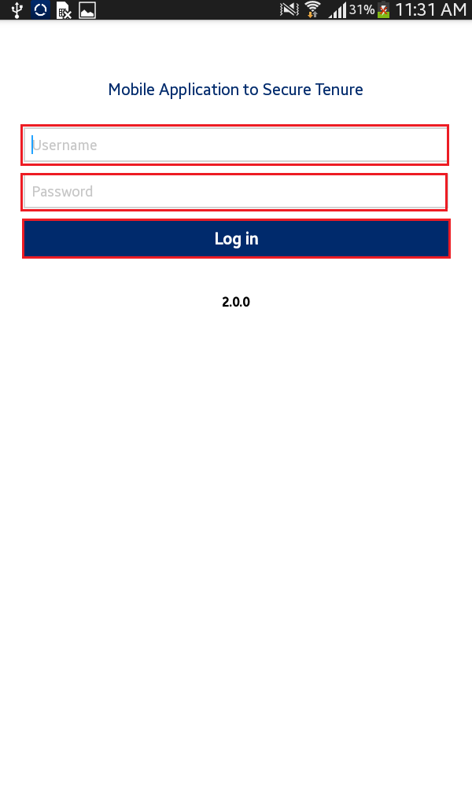Click on ‘Login’ button
3. Application will open up homepage of application
4. Following functionalities are visible:
   * + Map Viewer
     + Capture Data
     + Review Data
     + Verify Data
     + Download Data
     + Synchronize Data
     + User Preferences
     + Logout

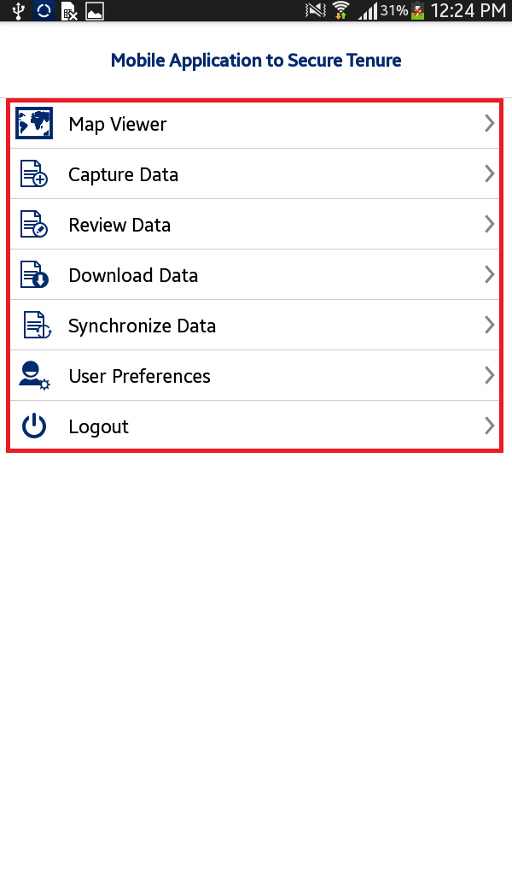

**Note – If ‘Adjudicator’ user logs in into MAST, the following functionalities are visible:**

* + - Map Viewer
    - Verify Data
    - Download Data
    - Synchronize Data
    - Download Final Data
    - User Preferences
    - Logout

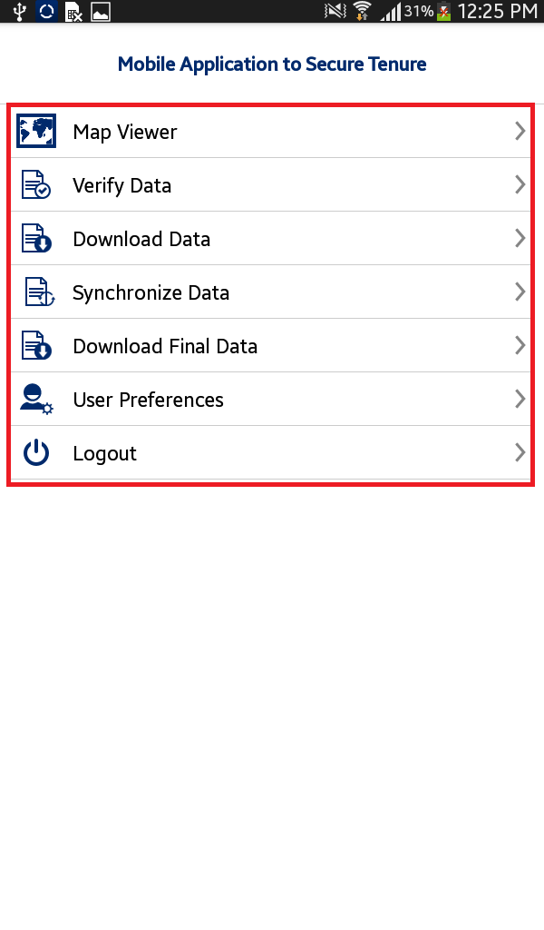

1. Map Viewer

This functionality allows authorized user/s to view spatial data of parcels and download the base map. Overall, map viewer will display following data layers:

* + - Base map (Satellite data downloaded from server)
    - Google base map
    - Collected parcel data (if collected by the user)

This functionality provides following facilities:

* + - View Base Data on map
    - Capture Spatial Data
    - Review Captured Data
    - Navigation Tools
    - Mapping Tools
      * Zoom to location
      * Enter X and Y coordinates
      * Measure
      * Info

**Steps:**

1. 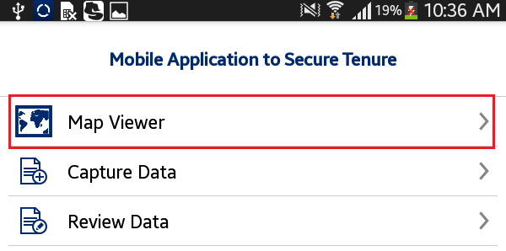Click on ‘Map Viewer’ option available on home page
2. Application will open up Map Viewer. Following tools are available with map viewer:
   * + Layer Manager
     + GPS
     + Get Location co-ordinates
     + Measure
     + Map Info
     + Bookmark
     + Capture Data
     + 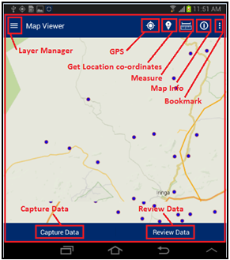Review Data

# Layer Manager

This functionality provides the listing of layers configured for the selected project. The user selects On/Off to display a particular layer from the Layer Manager to view on the map.

**Steps:**

1. 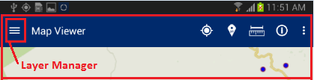Click on Layer Manager option available on top left
2. List of layers configured for the selected project will be displayed along with a check box. Check/Uncheck the checkboxes on Layer Manager to show/hide a particular layer on the map

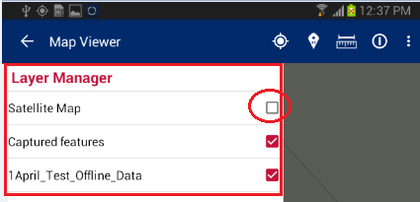

1. 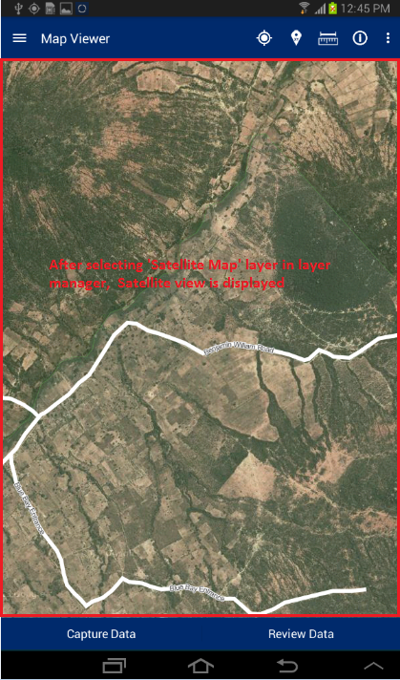 Selected layer will become available on map

# GPS

This functionality allows the user to navigate on the map to the current location.

**Steps:**

1. 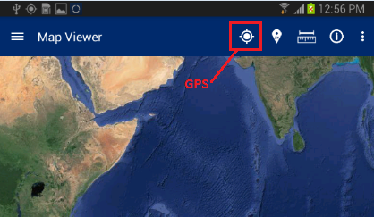Tap on ‘GPS’ option available on top right
2. Map will navigate to the current location

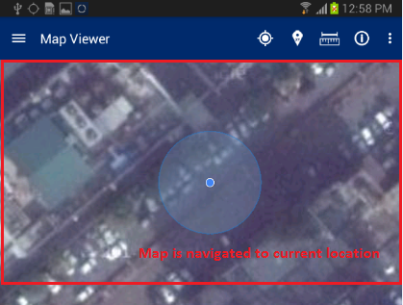

# Get location co-ordinates

This functionality allows the user to get coordinate values of specified location of map.

**Steps:**

1. Tap on ‘Get location Co-ordinates’ option available on top right

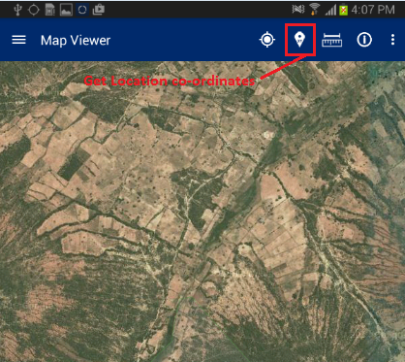

1. Click on map
2. ‘Co-ordinates from Map’ dialogue box will be displayed with coordinates of location specified by click on map

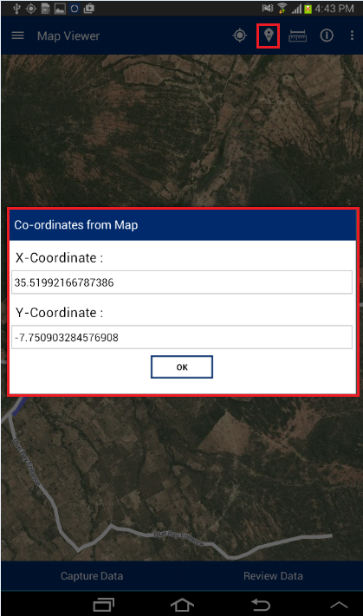

# Measure

This functionality allows the user to measure the area of any polygon, length of any line or the distance between two points on the map.

**Steps:**

1. Tap on ‘Measure’ option available on top right

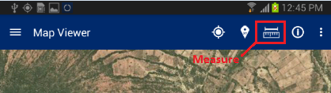

1. ‘Select feature to measure’ dialogue will be displayed with following options –
   * + Calculate Distance
     + Calculate Area
     + Measure Polygon Area
     + Measure Line Length

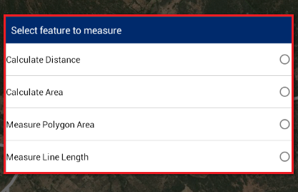

## Calculate Distance

This functionality allows the user to calculate the distance between two or more subsequent points on map.

**Steps:**

1. Tap on ‘Measure’ option available on top right
2. Select ‘Calculate distance’ option

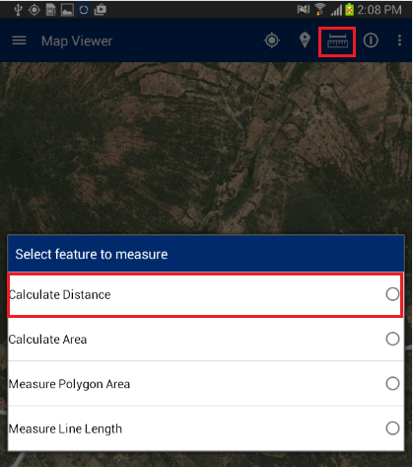

1. Click on map to specify at least two points
2. 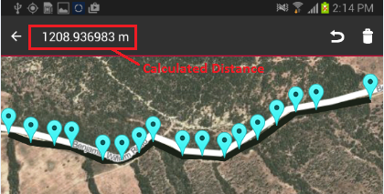Application will calculate distance and display it on top right of application

## Calculate Area

This functionality allows the user to calculate the area of a polygon by specifying it on map.

**Steps:**

1. Tap on ‘Measure’ option available on top right
2. Select ‘Calculate Area’ option

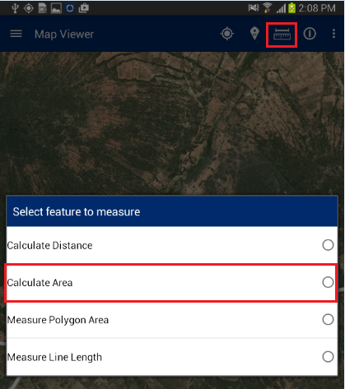

1. Click on map to specify at least three points
2. 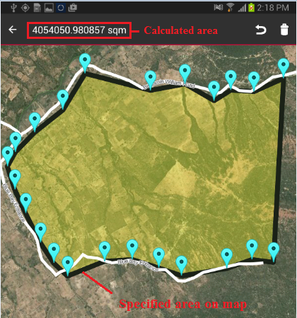Application will calculate area and display it on top right of application

## Measure Polygon Area

This functionality allows the user to calculate the area of the existing polygon feature by specifying it on the map.

**Steps:**

1. Tap on ‘Measure’ option available on top right
2. 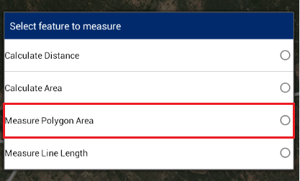Select ‘Measure Polygon Area’ option
3. Click on existing polygon feature map
4. Application will calculate area and display it on the map only

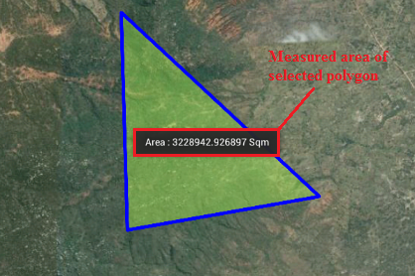

## Measure Line Length

This functionality allows the user to calculate the length of an existing line feature by specifying it on the map.

**Steps:**

1. Tap on ‘Measure’ option available on top right
2. 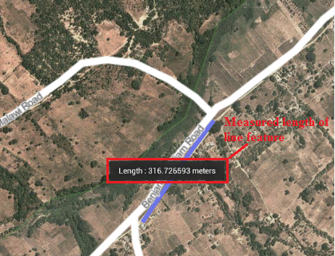Select ‘Measure Line Length’ option
3. Click on existing line feature map
4. 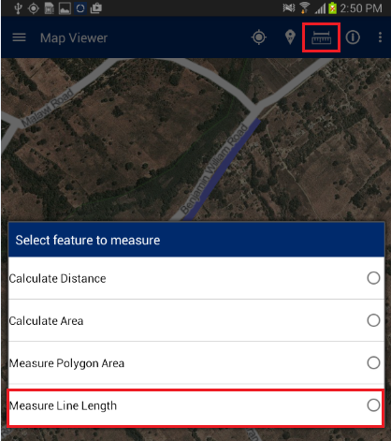Application will calculate length and display it on map only

# map Info Tool

This functionality allows the user to view the attribute details of any spatial feature which is already created on map.

**Steps:**

1. Navigate to existing feature on map;

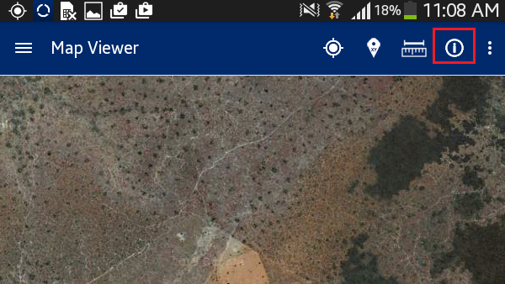tap on ‘Map Info’ option available on top right

1. Click on feature on map
2. Attribute details of specified feature will be displayed

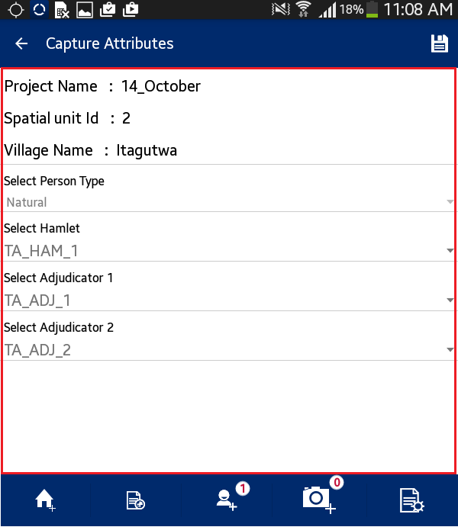

# Add/View Bookmark

This functionality allows the user to save a particular area of interest of on the map canvas for future reference. It also facilitates user to navigate a selected bookmark.

**Steps:**

1. 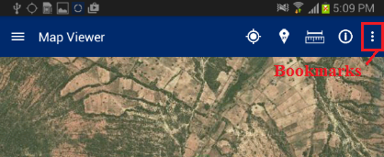Tap on ‘Add/View Bookmark’ option available on top right
2. Application will display two options:
   * + Add Bookmark
     + 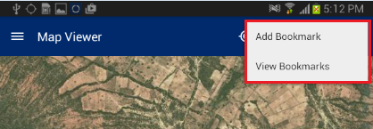View Bookmark

## Add Bookmark

This functionality allows the user to save a particular area of interest on the map canvas and save for future reference.

**Steps:**

1. Click on ‘Add Bookmark' option
2. Enter Bookmark dialogue box will be displayed
3. Enter desired name in input box
4. Click on ‘Save’ button
5. 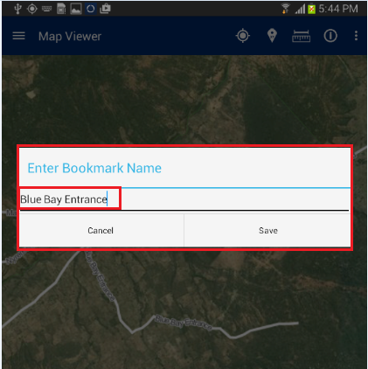Bookmark will be saved with entered name and will become available in ‘Select Bookmark' dialogue

## View Bookmark

This functionality allows the user to navigate a selected bookmark.

**Steps:**

1. Click on ‘View Bookmark' option
2. 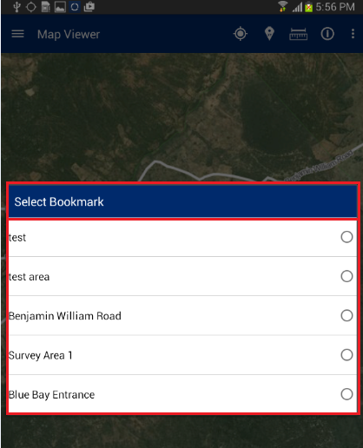‘Select Bookmark' dialogue box will be displayed with list of all bookmarks available
3. Select required bookmark
4. 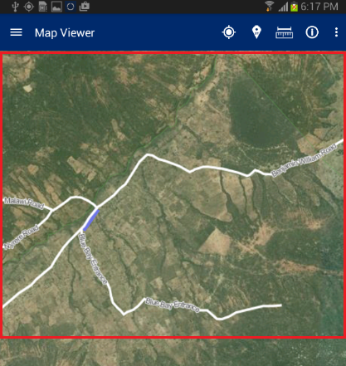Map will navigate to the location saved with selected bookmark
5. Download Data

This functionality allows the user to download configuration information and base data (satellite imagery and vector data which will be used as reference for the data collection process) on the device. To download data, the mobile device should be in connected mode, i.e. internet should be available in device.

**Steps:**

1. Click on ‘Download Data’ option available in homepage
2. Application will connect to the remote server and download required data

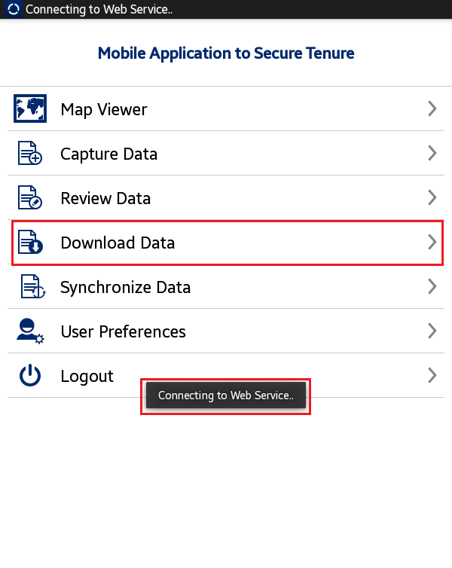

1. 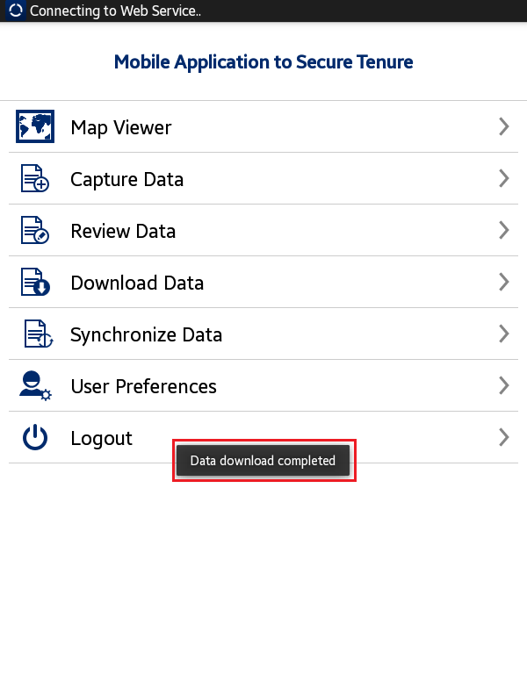Once Data Download is completed, an acknowledgement message will be displayed

1. Verify Data

This functionality allows an Adjudicator user to verify and approve the parcel as completed and synced by Trusted Intermediaries in the field.

**Steps:**

1. ‘Adjudicator’ user logs into the application
2. Application will open up homepage of application.
3. Following functionalities are visible:
   * + Map Viewer
     + Verify Data
     + Download Data
     + Synchronize Data
     + Download Final Data
     + User Preferences
     + Logout
4. 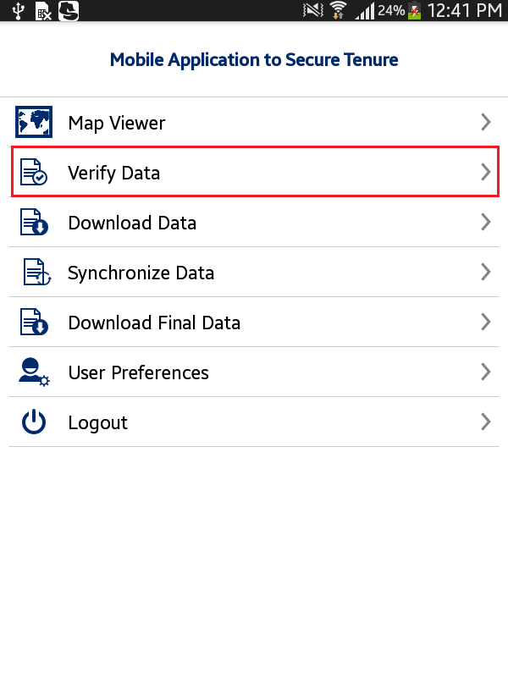Click on ‘Verify Data’ option available in Home page
5. Verify Data form will be displayed with following lists:
   * + Pending
     + Verified
     + Final

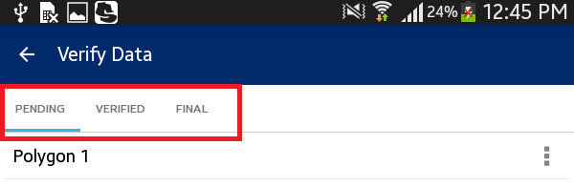

# Pending

The ‘Pending’ list displays all the parcels that are pending verification by the user. The following actions can be performed on a parcel which is in the pending list:

* + - View Map
    - View Attributes
    - Mark as Verified

**Steps:**

1. Click on ‘Action’ option available with parcel record in ‘Pending’ list
2. List of available possible actions will be displayed
   * + View Map
     + View Attributes
     + Mark as Verified

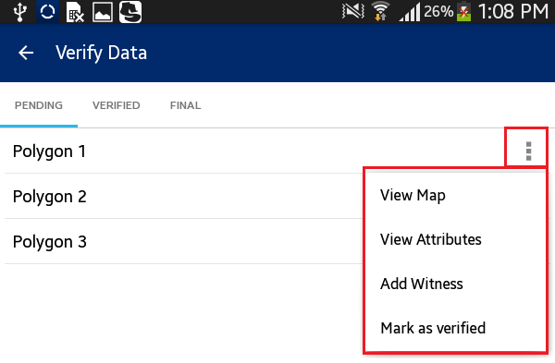

## View Map

This functionality allows the user to edit spatial data.

**Steps:**

1. 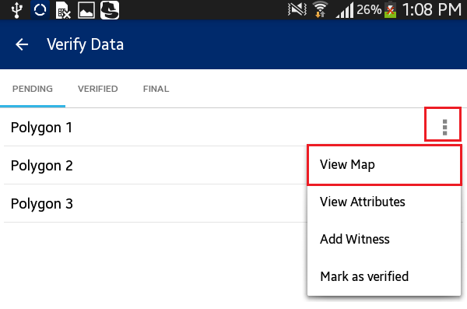Click on ‘View Map’ option
2. User will navigate to the map and corresponding feature will be available in edit mode
3. Select node/vertices by long pressing the node/vertices and edit the same
4. Click on ‘Save’ option
5. 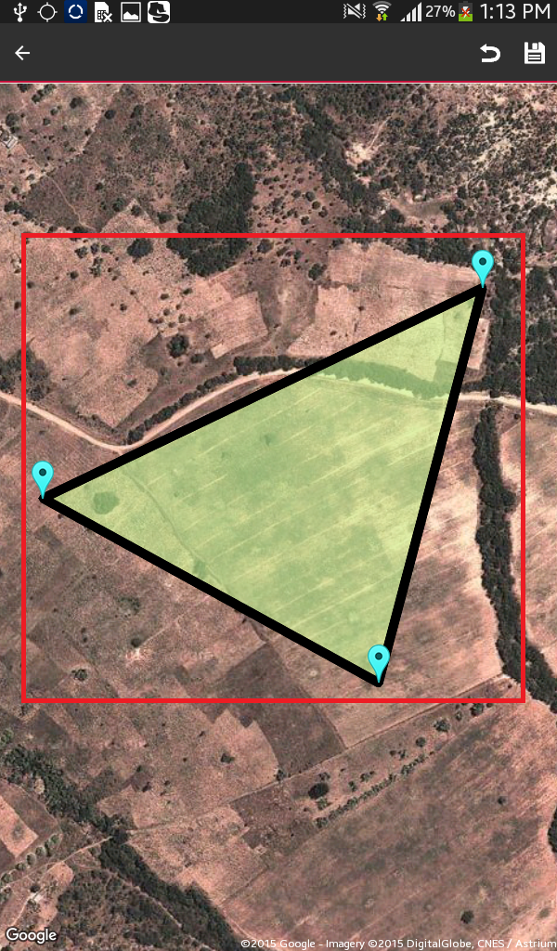Application will save updated spatial feature

**Note: In case feature is not visible, click on back arrow button on left hand top of screen. Click on Capture Spatial data icon. Application will open up Layer Manager. Switch on Captured Features layer.**

## View Attributes

This functionality allows the user to view attribute data of a spatial unit.

**Steps:**

1. 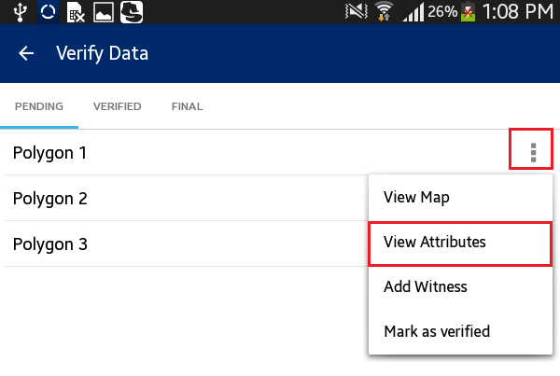Click on ‘View Attributes’ option
2. 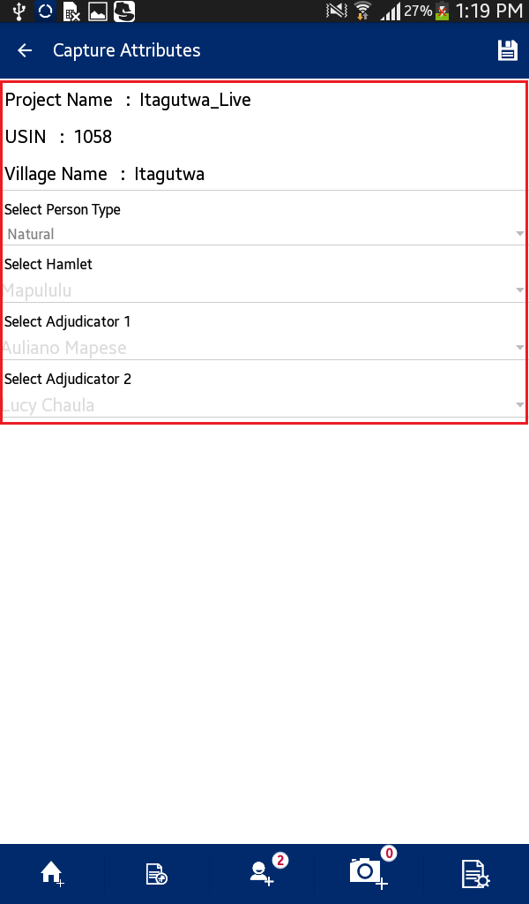The user will navigate to the ‘Capture Attributes' form and attributes of corresponding feature will be available in read-only mode

## Mark as Verified

This functionality allows the user to mark a parcel as `Verified.”

**Steps:**

1. 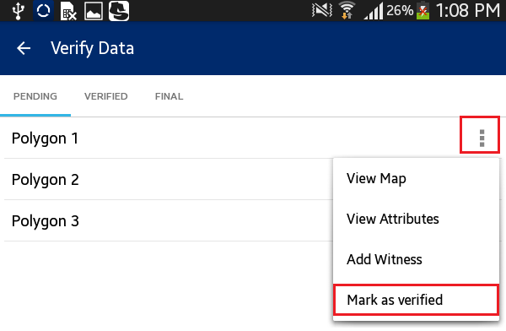Click on ‘Mark as Verified’ option
2. Application will display a confirmation message along with ‘Cancel’ and ‘OK’ button
3. Click on OK button
4. 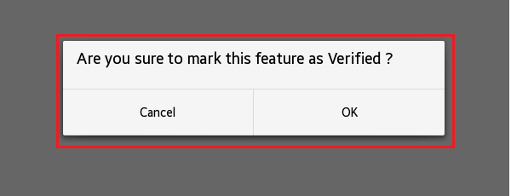Parcel will be verified. It will be removed from the ‘Pending’ List and will become available in the ‘Verified’ List

# Verified

‘Verified’ list displays all the parcels that have been marked as verified by the user.

**Steps:**

1. ‘Adjudicator’ user logs into the application
2. Application will open up homepage of application
3. User clicks on ‘Verify Data’ option available in homepage
4. Tap the device
5. 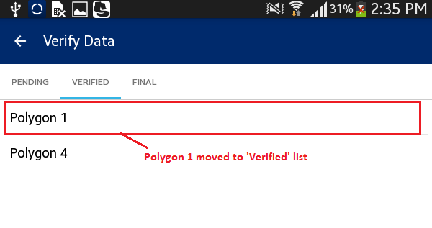'Verified list' will be displayed

# Final

‘Final’ list displays all the parcels that have been marked as final in web application.

**Steps:**

1. ‘Adjudicator’ user logs into the application
2. Application will open up homepage of application
3. User clicks on ‘Verify Data’ option available in homepage
4. Tap the device
5. 'Final list' will be displayed
6. Click on ‘Action’ option available with parcel record in ‘Final’ list

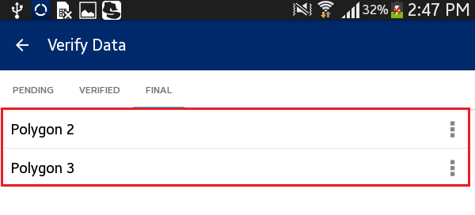

1. List of available possible actions will be displayed:
   * + View Map
     + View Attributes
     + 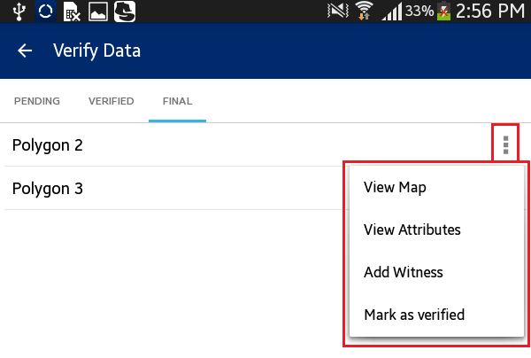Mark as Verified
2. Capture Data

This functionality allows authorized user/s to capture spatial data of parcels on map. This functionality allows users to: Capture New Data (Point, Line and Polygon), Edit Data (Attribute and GIS data), Delete Data, Measure and view Info of selected feature.

**Steps:**

1. 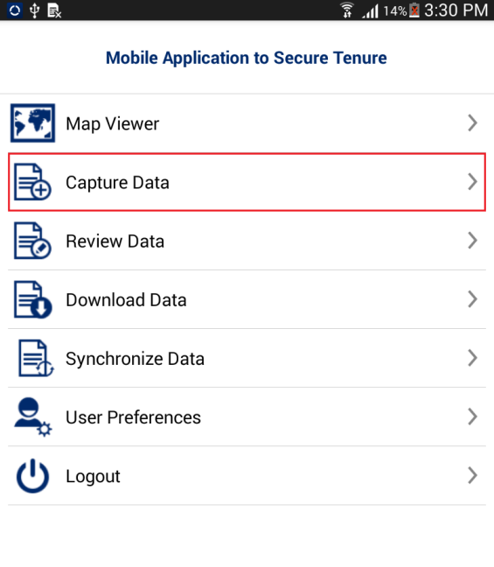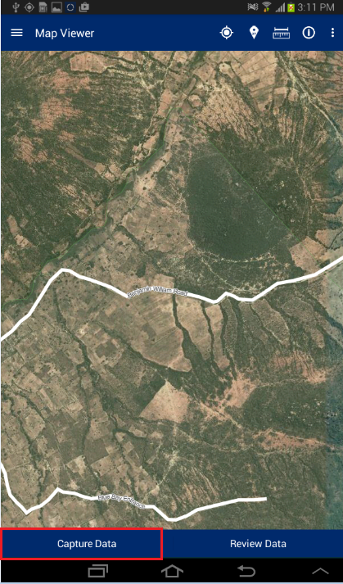Click on ‘Capture Data’ button available in Map Viewer

**Note: User can navigate directly to ‘Capture Data’ functionality by clicking on ‘Capture Data’ option available in homepage.**

1. Application will open ‘Capture Data’ window. The following tools are available with the ‘Capture Data’ window:
   * + Layer Manager
     + Zoom to Current Location
     + Add Bookmark
     + View Bookmark
     + Add Feature
     + Edit Spatial
     + Delete Feature
     + Measure Tool
     + 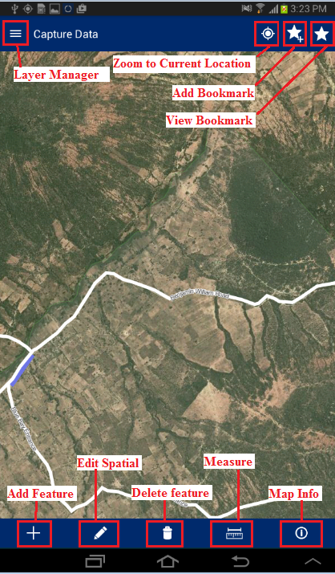Map Info

# Layer Manager

This functionality provides the listing of layers configured for the selected project. User can select On/Off display of a particular layer from the Layer Manager to view on the map.

**Steps:**

1. Click on `Layer Manager’ option available on top left

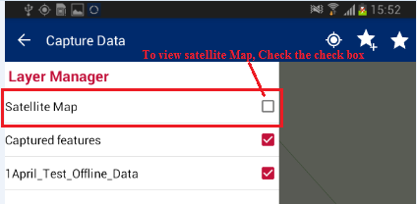

Check the ‘Checkbox’ associated with layer

1. 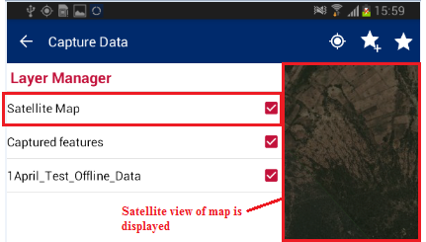Selected layer will become visible on map

# Zoom to Current Location

This functionality allows the user to navigate on the map to the current location.

**Steps:**

1. 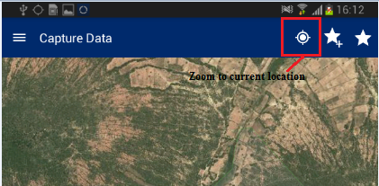Tap on ‘Zoom to current location' option available on top right
2. 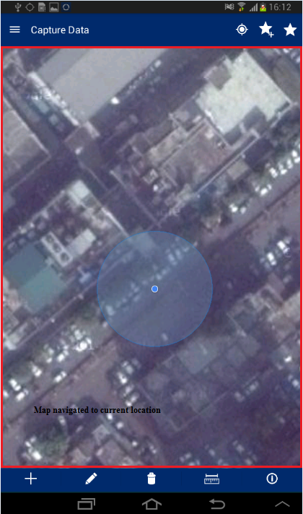Map will navigate to the current location

# Add Bookmark

This functionality allows the user to save a particular area of interest of the map canvas for future reference.

**Steps:**

1. Tap on ‘Add Bookmark’ option available on top right
2. ‘Enter Bookmark Name’ dialogue box will be displayed
3. Enter desired name in input box and click on ‘Save’ button
4. 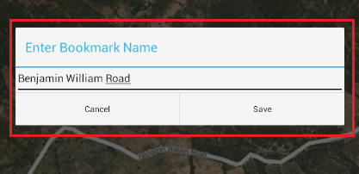Bookmark will be saved with entered name and will become available in ‘Select Bookmark’ dialogue

# View Bookmark

This functionality allows the user to navigate to a selected bookmark.

**Steps:**

1. Tap on ‘View Bookmarks’ option available on top right

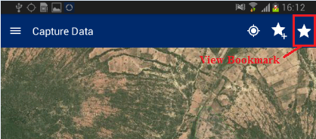

‘Select Bookmark’ dialogue box will be displayed with list of all bookmarks available.

1. Select required bookmark
2. 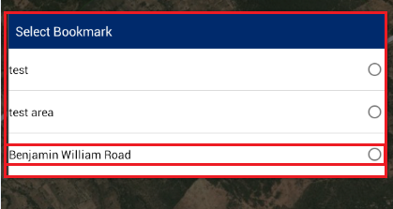Map will navigate to the location saved with selected bookmark

# Add Feature

This functionality provides multiple tools to capture spatial data on the map. These tools are point, line, and polygon. These features can be created via ‘manual drawing’ or via GPS.

**Steps:**

1. Tap on ‘Add Feature’ option available on bottom tool box

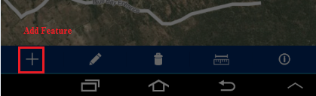

1. ‘Capture Data’ dialogue box will be displayed with following options:
   * + Capture Point
     + Capture Line
     + Capture Polygon

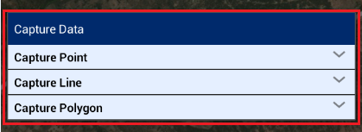

## Capture Point

‘Capture Point’ option allows the user to capture a point on the map. User can capture a point manually, using GPS or by entering location coordinates.

**Steps:**

1. Tap the option ‘Capture Point’
2. The following options will be displayed:
   * + Draw Point
     + Capture point by GPS
     + 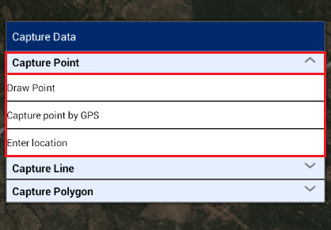Enter Location

### Draw Point

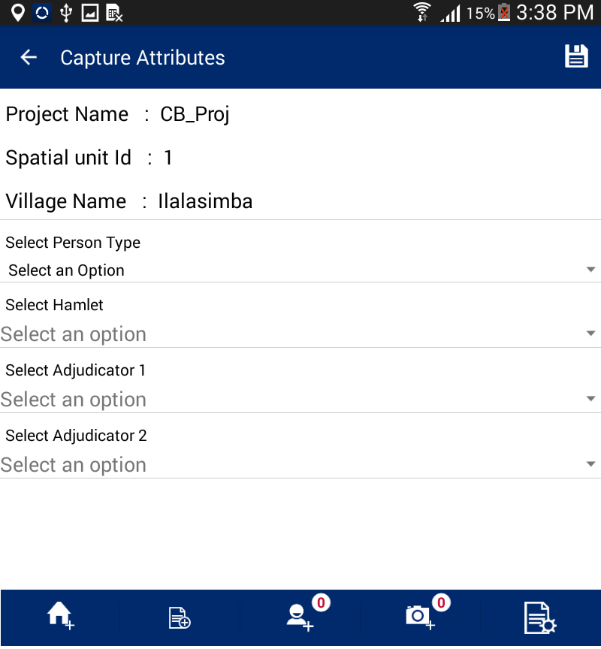This functionality allows the user to draw a point on the map manually by clicking on a specific location on the map.

1. Select the option ‘Draw Point’
2. Click on map
3. Marker will be placed on specified location
4. Click on ‘Save’ on top right
5. Point placed on map will be saved and ‘Capture Attribute’ form will be displayed

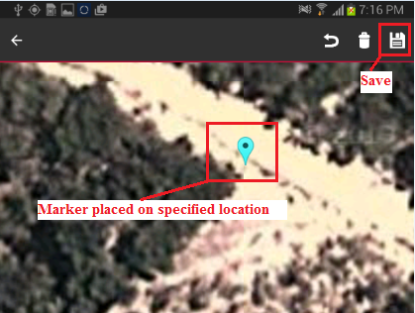Capture point by GPS

This functionality allows the user to draw a point on the current location using GPS. Pre-requisite: GPS should be enabled on the device.

1. 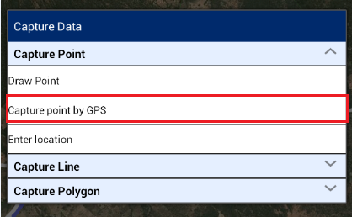Select the option ‘Capture point by GPS’
2. Click on ‘Plot point by GPS’ option available on top left
3. Marker will be placed on current location using GPS
4. Click on Save option available on top right
5. Point placed on map will be saved and ‘Capture Attribute’ form will be displayed

### Enter Location

This functionality allows the user to draw a point at a location specified by entered coordinates.

1. 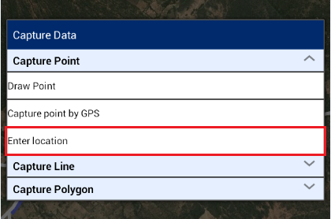Select the option ‘Enter Location’
2. Co-ordinate from map dialogue will be displayed
3. Enter coordinate values like X as 35.521124, Y as -7.743804
4. 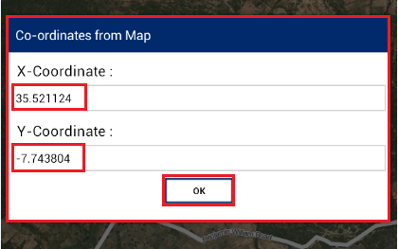Click on OK button
5. Marker will be placed on specified co-ordinates
6. Click on Save option available on top right
7. 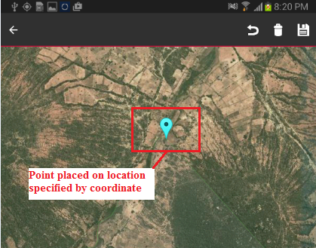Point placed on map will be saved and ‘Capture Attribute’ form will be displayed.

## Capture Line

This functionality allows the user to capture a line on the map. The user can capture a line manually by clicking on the map or by using GPS.

**Steps:**

1. Tap the option ‘Capture Line’
2. Following options will be displayed:
   * + Draw Line
     + 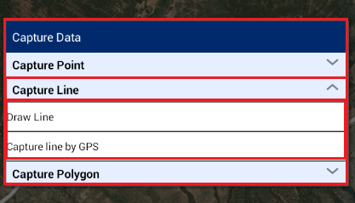Capture Line by GPS

### Draw Line

This functionality allows the user to draw a line on the map manually by clicking on selected locations on the map.

1. Select the option ‘Draw Point’
2. 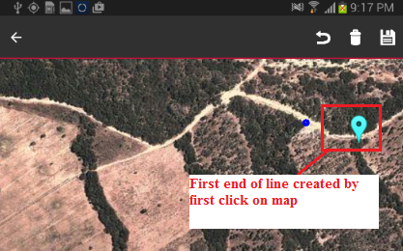Click on the map; on first click, first end of a line will be created
3. Click on a second (or more) location/s on the map to create the end of line
4. 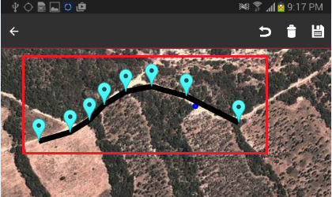Markers will be placed on clicked locations and a line will be created
5. Click on `Save’ option available on top right
6. Line placed on map will be saved and ‘Capture Attribute’ form will be displayed

### Capture Line by GPS

This functionality allows the user to draw a point at current location using GPS.

1. 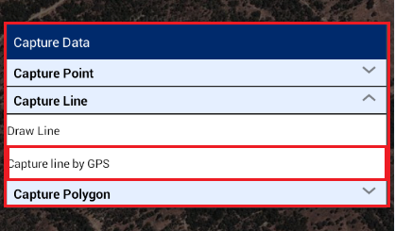Select the option ‘Capture line by GPS’
2. Click on ‘Plot point by GPS’ option available on top left
3. Marker will be placed on current location using GPS
4. Move the device to second location and click on ‘Plot point by GPS’
5. Marker on current location using GPS
6. Click on `Save’ option available on top right
7. Line placed on map will be saved and ‘Capture Attribute’ form will be displayed

## Capture Polygon

This functionality allows the user to capture a polygon on the map. The user can capture a polygon manually by clicking on the map or by using GPS.

**Steps:**

1. Tap the option ‘Capture Polygon’
2. Following options will be displayed
   * + Draw Polygon
     + 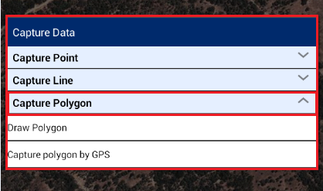Capture Polygon by GPS

### Draw Polygon

This functionality allows the user to draw a polygon on the map manually by clicking on desired locations on the map.

1. Select the option ‘Draw Polygon’

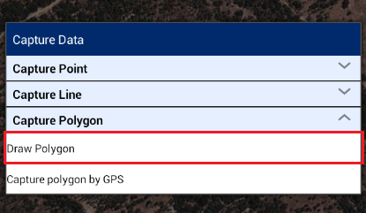

1. Click on map. On first click, first vertex of the polygon will be created
2. Next, click on second, third or more locations on map to create polygon
3. Markers will be placed on clicked locations and polygon will be created
4. 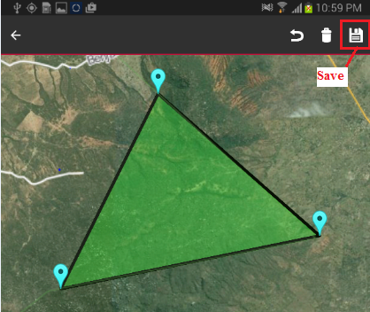Click on `Save’ option available on top right
5. Polygon placed on map will be saved and ‘Capture Attribute’ form will be displayed

### Capture Polygon by GPS

This functionality allows the user to draw a polygon covering selected locations using GPS.

1. 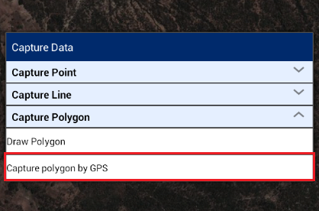Select the option ‘Capture Polygon by GPS’
2. Click on ‘Plot point by GPS’ option available on top left
3. Marker will be placed on current location using GPS
4. Move the device to second location and click on ‘Plot point by GPS’
5. Marker on second location will be placed on current location using GPS
6. Move the device to third or more locations and click on ‘Plot point by GPS’
7. Marker will be placed on current location using GPS and a polygon will be created
8. Click on `Save’ option available on top right
9. 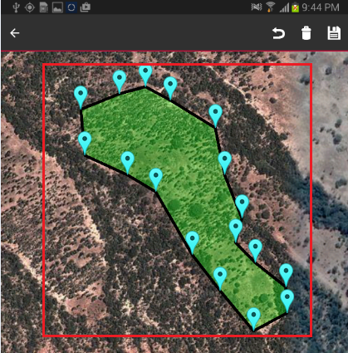Polygon placed on map will be saved and ‘Capture Attribute’ form will be displayed

# Capture Attribute

Once any spatial data (line, point or polygon) is captured on the map, the user will be able to capture attribute and multimedia data for the spatial unit. Attributes that will be captured are configurable by the mobile configuration tool of the web application.

**Steps:**

1. After creating the spatial data, a user clicks on the ‘Save’ option available on top left of screen.
2. The Application will save the spatial data and ‘Capture Attributes’ form will be displayed with following options:
3. Select Person Type
4. Select Hamlet
5. Select Adjudicator 1
6. Select Adjudicator 2

This form will be the general category, which the user will select the type of person, location, and witnesses. Enter general information and click on ‘Save’ option. The application will save the general information and ‘Add Property’ screen will be shown.

The Application facilitates user with following options:

* Add Property
* Add Social Tenure
* Add Person
* Add New Multimedia
* 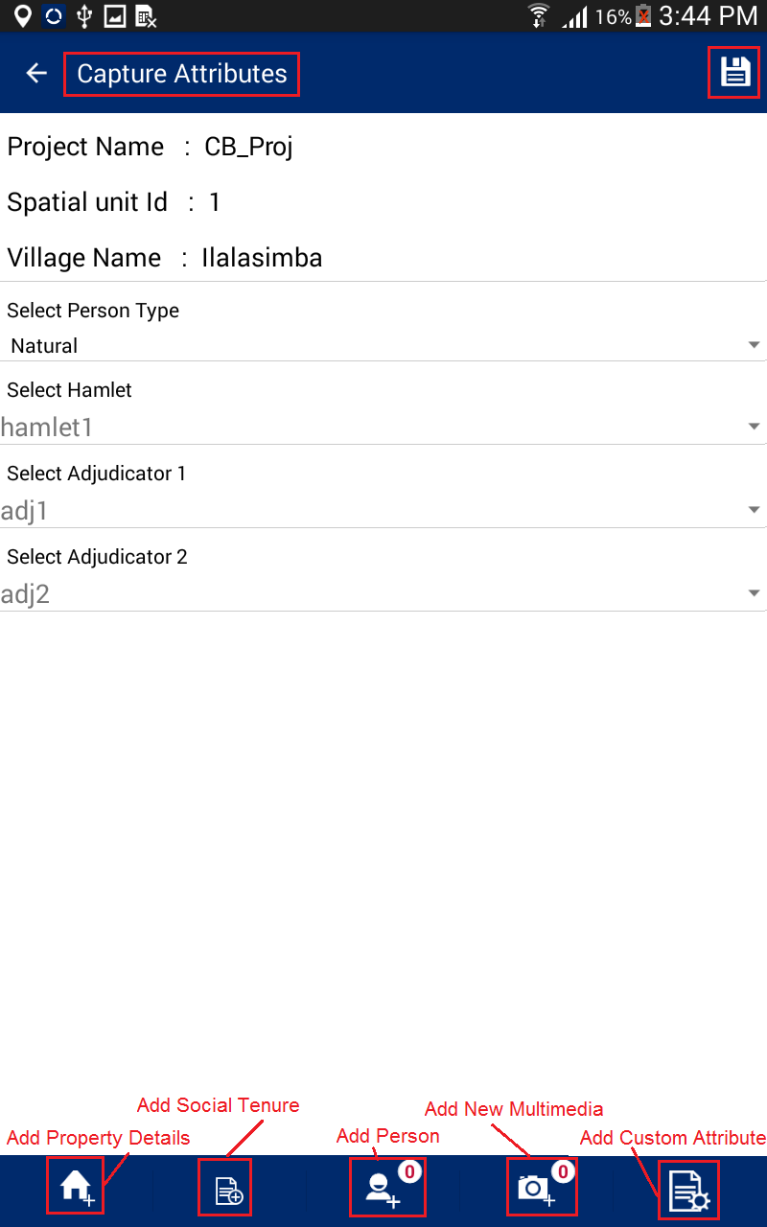Add Custom Attribute

1. Details will be saved and user will navigate to ‘Add Property Info’ form.

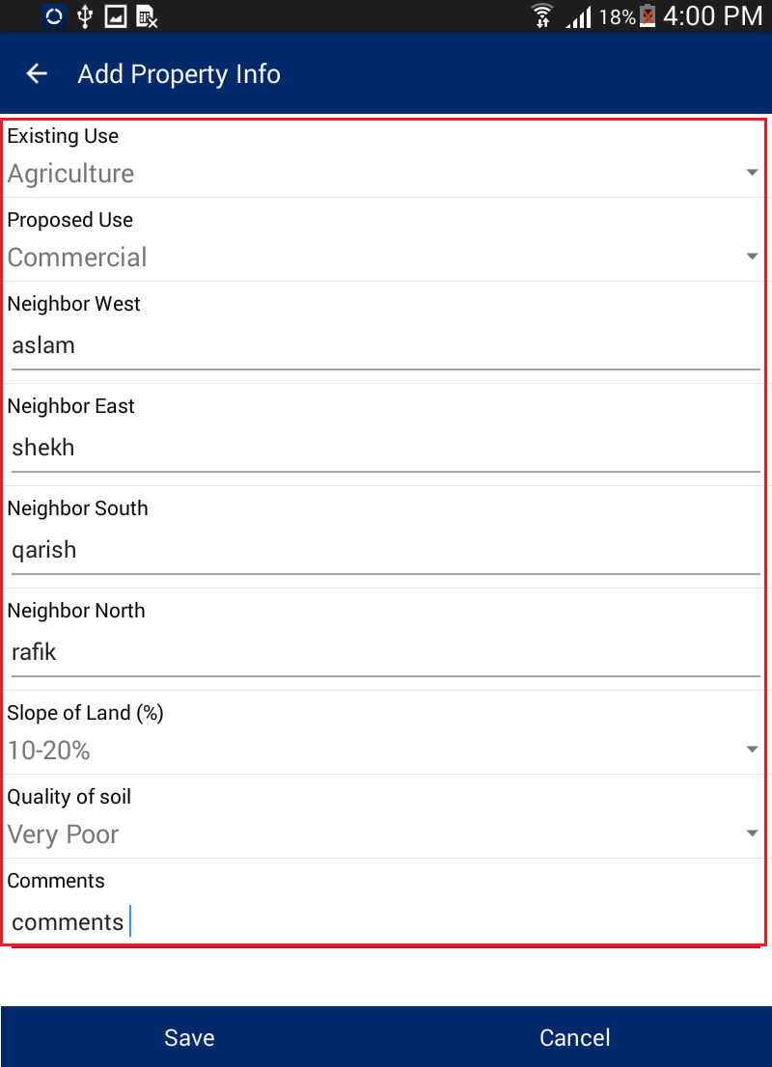In the Property Info screen, the user will be prompted to enter the required property details. Once the data is entered, the user will then click on the ‘Save’ option. The application will save the property information and the ‘Social Tenure’ screen will be shown.

1. In the Social Tenure screen, the user will enter required details and click on ‘Save’ button. The application will save the social tenure information and ‘Person Listing’ screen will be shown.

**Note: - As per the selection of person type in Capture Attributes, user will be able to select type of tenure in Add Social Tenure form.**

In Social Tenure the user selects details like Resident, Type of Tenure and Type of Right of Occupancy. After the selection of type of tenure the Add Person form will be shown.

There are five “Type of Tenure” for Natural Person. These are:

Multiple Occupancy (Tenancy in Common)

Single Occupant

Multiple Occupancy (Joint Tenancy)

Tenancy in Probate (Administrator)

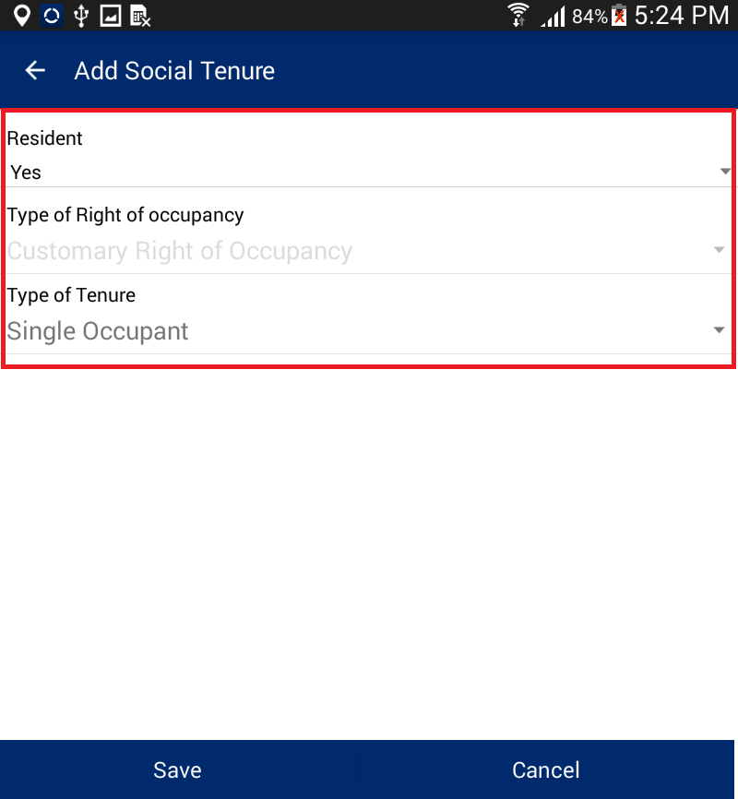Guardian (Minor)

* 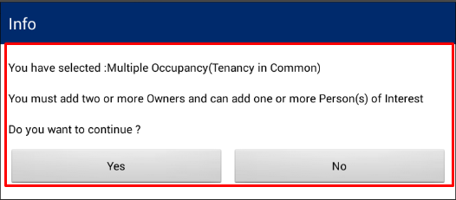**Multiple Occupancy (Tenancy in Common):** If the user selects this tenure type and saves the form, then the user will be prompted to add users in the Add Person form. The user will be required to add two or more “*Owners*” and there can add one or more “*Person(s) of Interest*”.
* **Single Occupant:** If the user selects this type of tenure, and saves the form, then the user will be prompted to add users in the Add Person form. In this case, the user will be required to add only one “*Owner*” and will have the possibility to add one or more “*Person(s) of Interest*”.

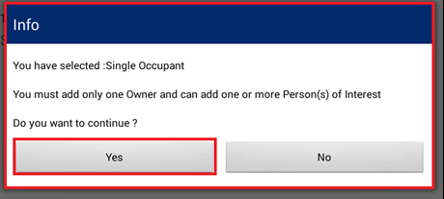

* **Multiple Occupancy (Joint Tenancy):** If the user selects this tenure type, then the user will be prompted to add users in the Add Person form. In the Add Person form, the user will be required to add two “*Owners*” and may add one or more “*Person(s) of Interest.*”

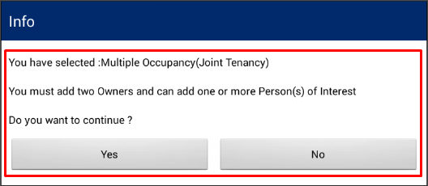

* **Tenancy in Probate (Administrator):** If the user selects this tenure type, then in the Add Person form the user will be required to add one or more “*Owner(s)*”. Based on the tenure selection, the user may and up to two “*Administrators*” and will also need to indicate the name of the “*Deceased Person*”. The user can also add one or more “*Person(s) of Interest*.”

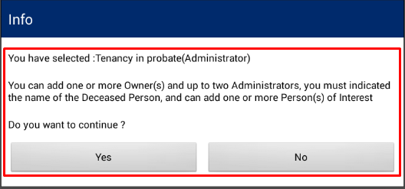

* **Guardian (Minor):** If the user selects this tenure type, then the user will be prompted to add users in the Add Person form. The user will be required to add one or more “*Minor*” and up to two “*Guardian*”.

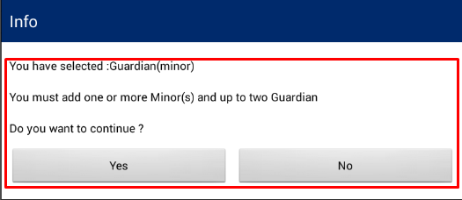

**Note:** It is mandatory to add photo for Owner, Administrator and Guardian**.**

Based on tenure type the user has selected, the user will be required to provide inputs available in ‘Add Person’ form; Click on ‘Save’ button.

1. 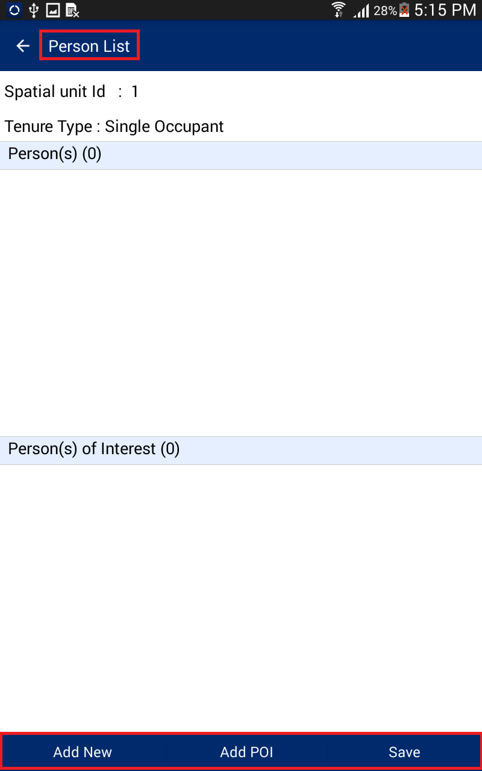Click on ‘Yes’ button available on displayed message box, User will be directed to the ‘Person List’ form.
2. 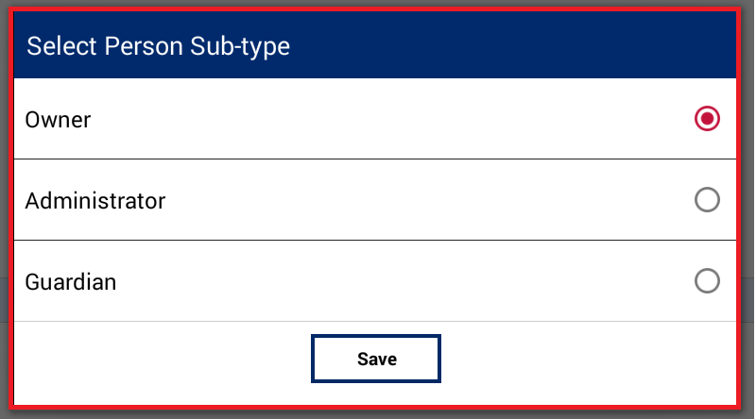Click on ‘Add New’ button, ‘Person Sub-type’ dialogue will be displayed. Select the required button; click on ‘Save’ button.
3. ‘Add Person’ form will be displayed. User will enter the desired attributes and click on ‘Save’ button.
4. 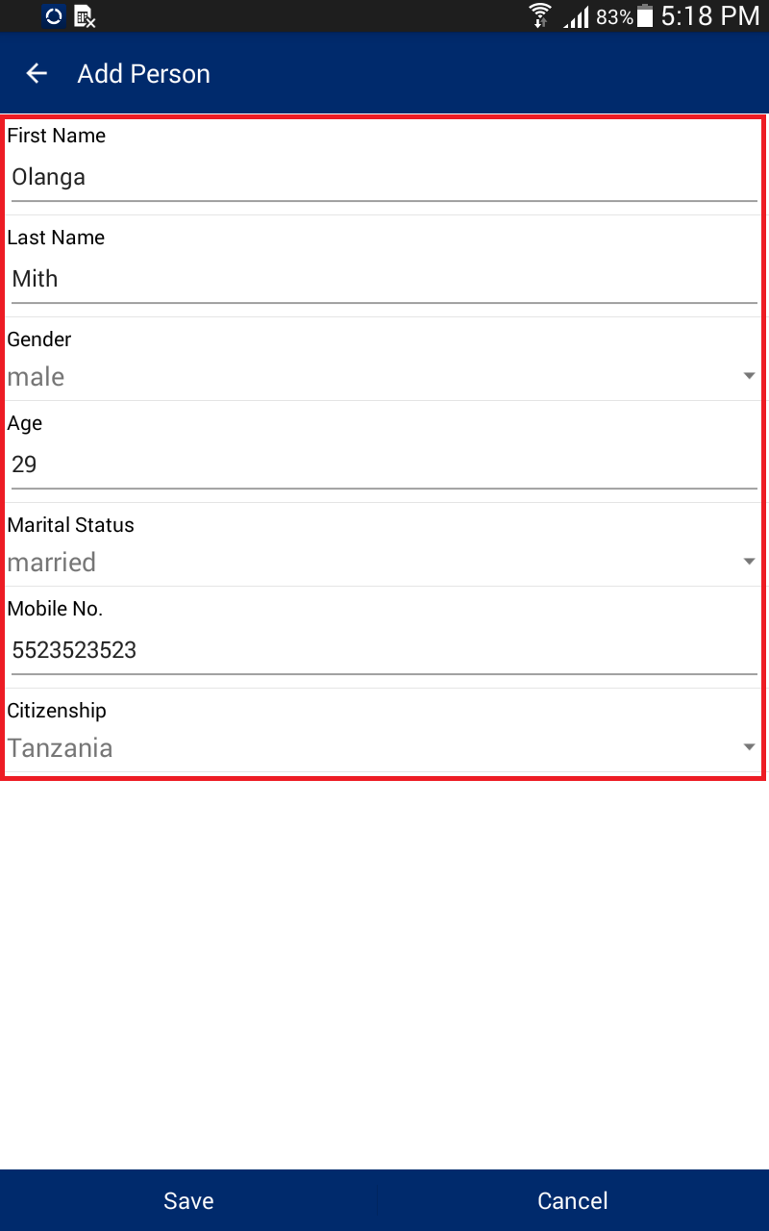Personal details will be saved and details will become available in corresponding section.
5. Click on option associated with record available in Person(s) section. The following options will be available:

* Edit Attribute
* Add Photo
* Delete Photo
* 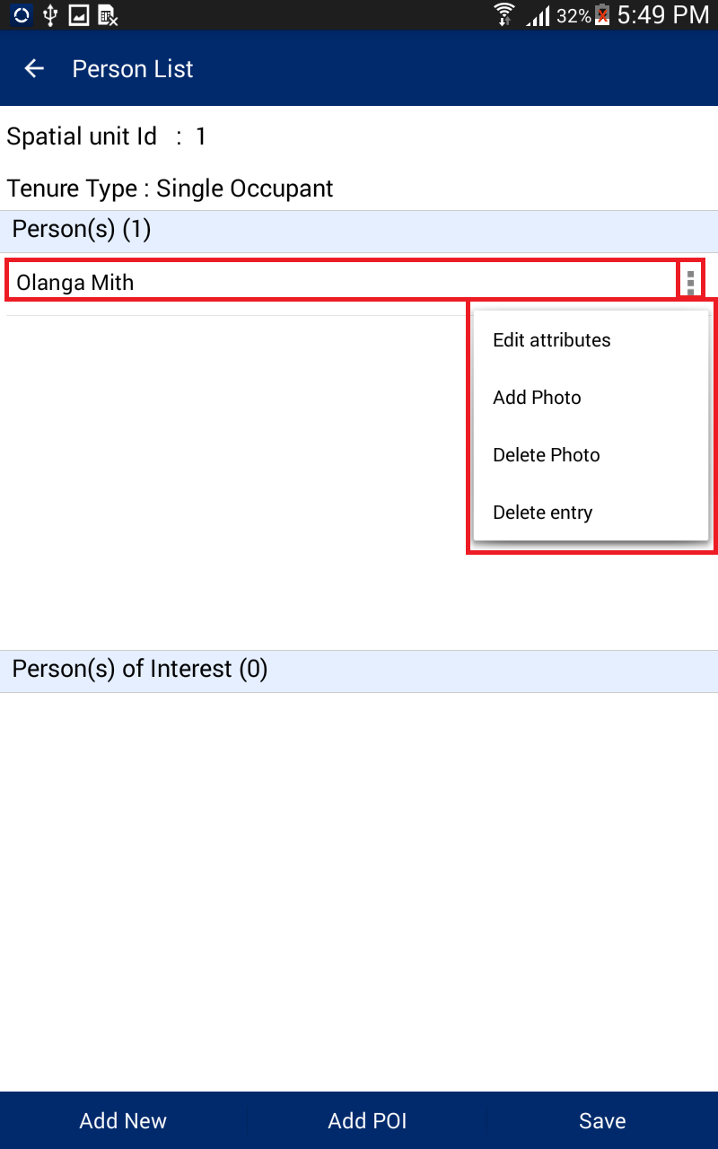Delete entry

**Note:**

* **Edit Attribute: ‘**Edit Attribute’ option will enable user to edit the current details of person.
* **Add Photo:** ‘Add Photo’ will enable user to take a photo of the person and associate it with details.
* **Delete Photo:** ‘Delete Photo’ will enable the user to delete an existing photo.
* **Delete entry:** ‘Delete Entry’ will enable user to delete the person’s details.

1. 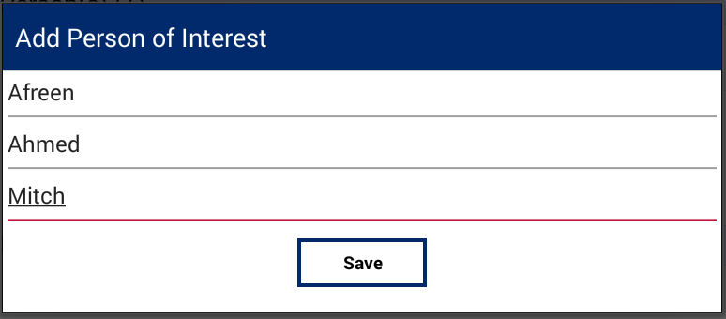Click on ‘Add POI’ button. ‘Add Person of Interest’ dialogue will be displayed. Provide the required details and click on ‘Save’ button.

**Note:** For person of interest, only the first, middle and last name are required**.**

1. Details of ‘Person of Interest’ will be saved and details will become available in corresponding section.
2. Click on option associated with record available in ‘Person(s) of Interest’ section, following options will be available:

* Edit
* 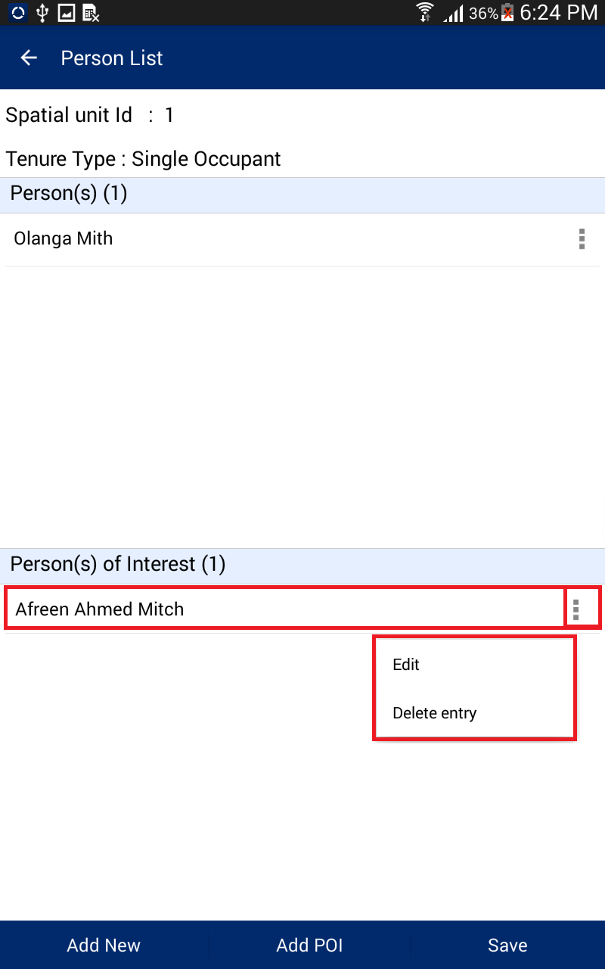Delete Entry

**Note:**

* **Edit: ‘Edit’ option will enable user to edit the current details of the person of interest.**
* **Delete entry: ‘Delete Entry’ will enable user to delete the person’s details.**

1. 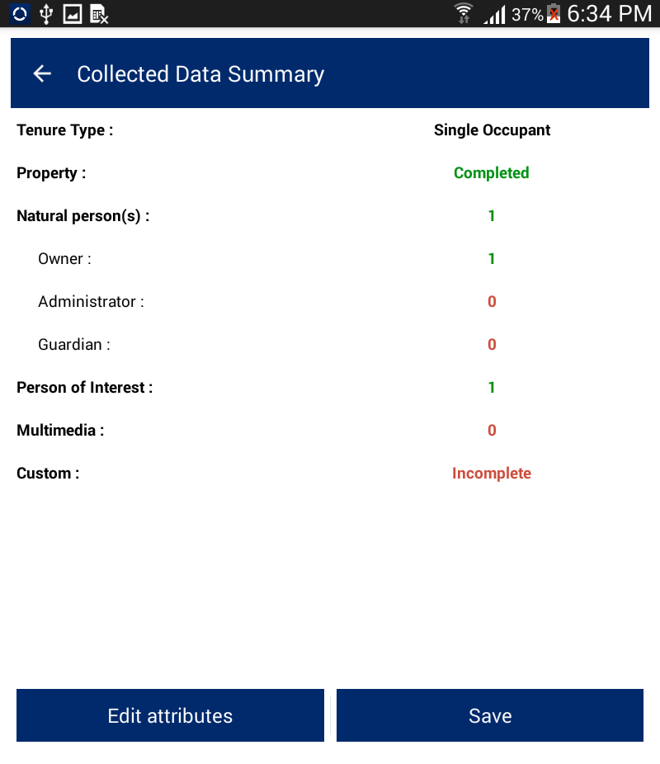Once required details are added, click on ‘Save’ button. ‘Collected Data Summary’ page will be displayed with summary of data captured.

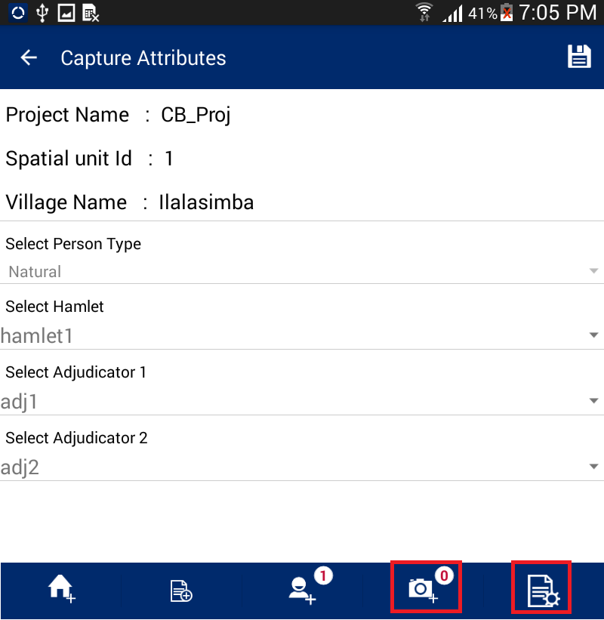If any of the details are incomplete, click on ‘Edit Attribute’ button, and the ‘Capture Attribute’ form will be displayed, Click on corresponding option available in bottom tool bar and complete the detail.

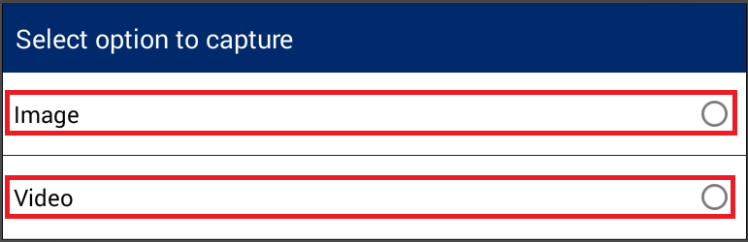For instance, if the user wants to enter additional multi-media information, the user can click on ‘Add New Multimedia’ option and the ‘Multimedia List’ form will be displayed.

1. Click on ‘Add New’ button.
2. The select Multimedia dialogue will be displayed, and the user can select Multimedia type, capture and save the same.
3. 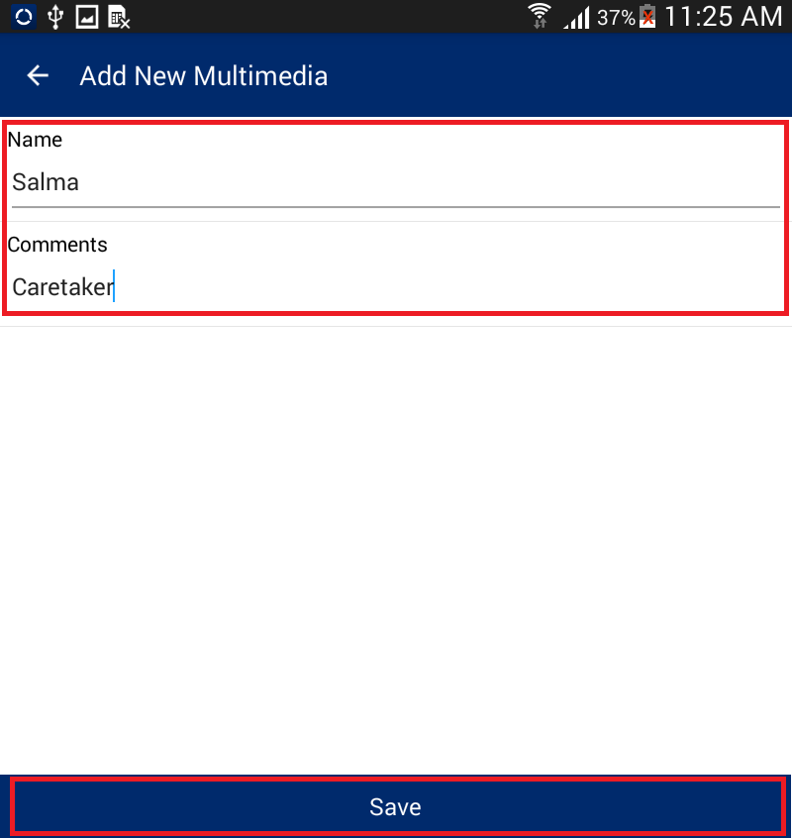Once the multimedia file is created, the user can provide details. The 'Add New Multimedia' form will be displayed. Enter details and click on ‘Save’ button.
4. Multimedia details will be saved and will be available in the ‘Multimedia List’. The following options will be available with the record:

* View Media
* Edit Attribute
* 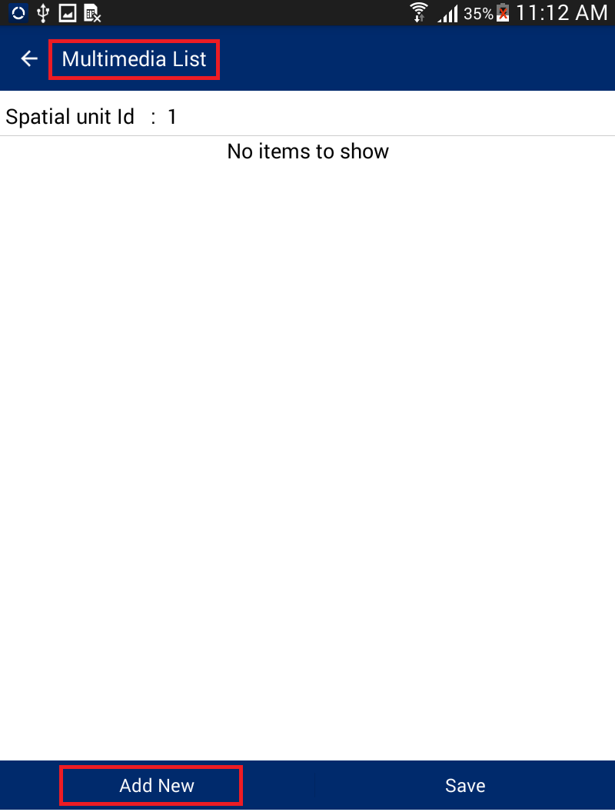Delete Entry

**Note:**

* **View Media:** Enables user to view attached multimedia
* **Edit Attribute:** Enables user to edit attributes associated with multimedia
* **Delete Entry:** Enables user to delete multimedia and associated attributes

1. Click on ‘Save’ button, ‘Collected Data Summary’ form will be displayed. Click on the ‘Edit attributes’ button. Numbers of attached Multimedia will be available along with ‘Add New Multimedia’ Option.

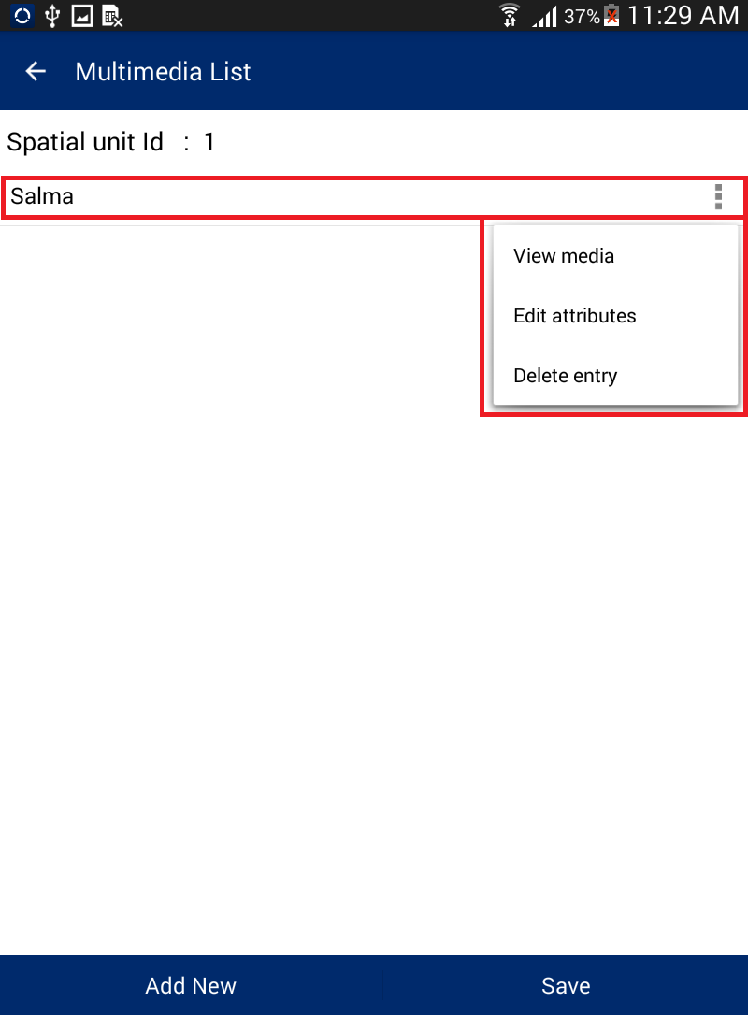The user can capture Image / Video. Once Image/Video is saved, these will get associated with the parcel.

Please note that custom attributes can be added to the mobile application through the configuration tool. If custom attributes have been added as part of the project, the user will have the option to fill in these attributes. To add custom attributes, the user may click on the ‘Add Custom Attributes’ option

1. 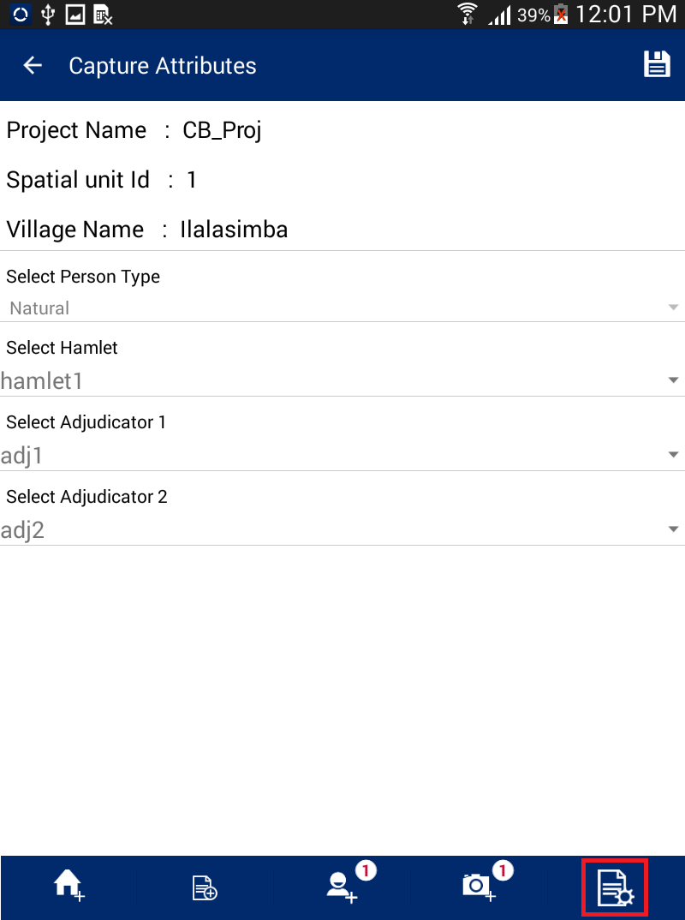The ‘Custom Attributes’ form will be displayed. Enter attribute details and click on ‘Save’ button.
2. 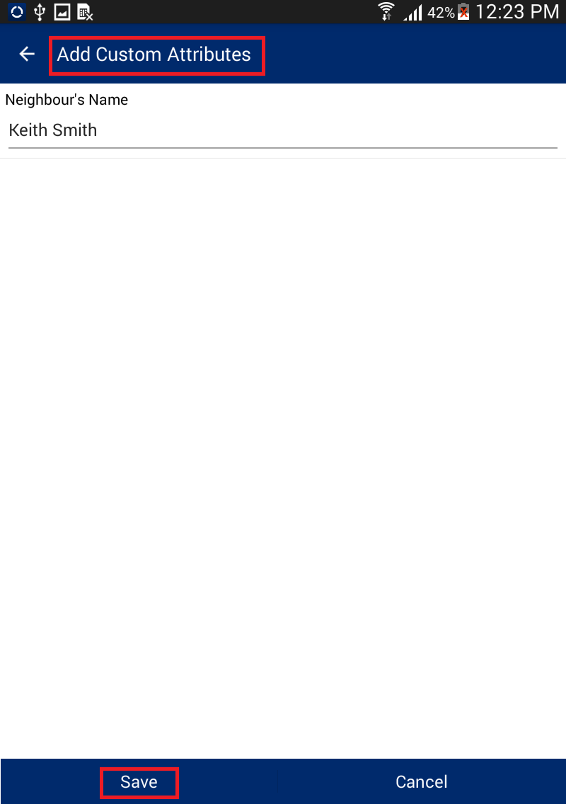Custom attribute details will be saved.

# Edit Spatial

This functionality allows the user to edit spatial data which has already been captured by the user.

**Steps:**

1. 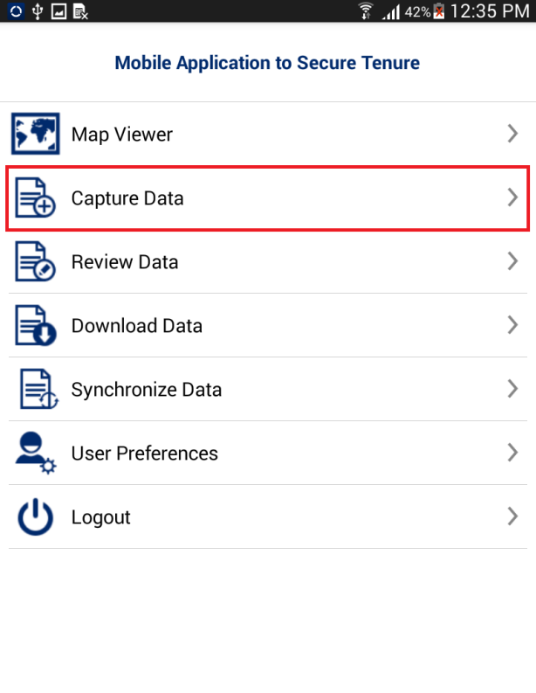Click on ‘Capture Data’ option available on home page
2. Navigate to parcel which is being edited
3. Click on ‘Edit Spatial’ data icon
4. 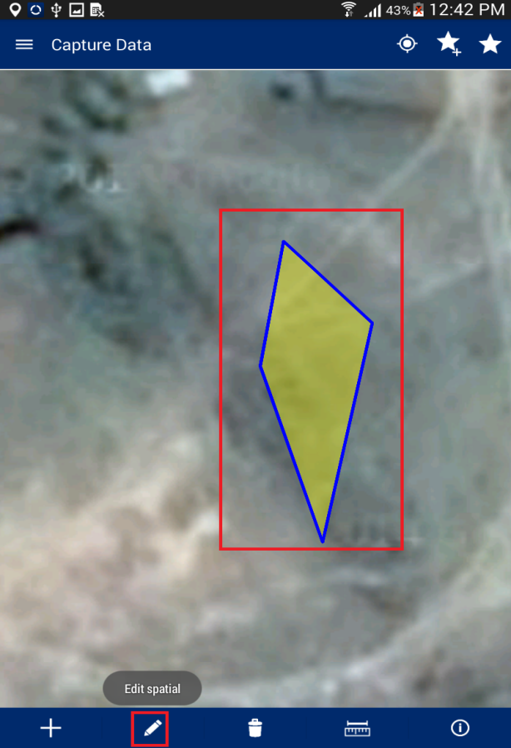Click on feature to be edited
5. Application will show nodes/vertices in editable format
6. Select node/vertices by long pressing the node/vertices and move these

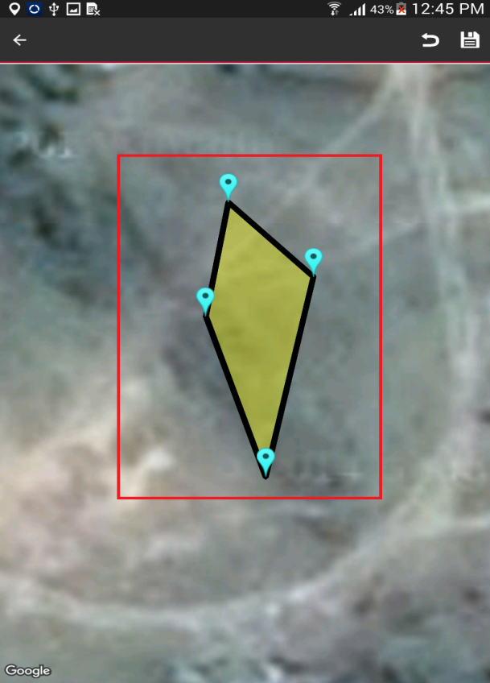

1. Click on ‘Save’ on right top
2. 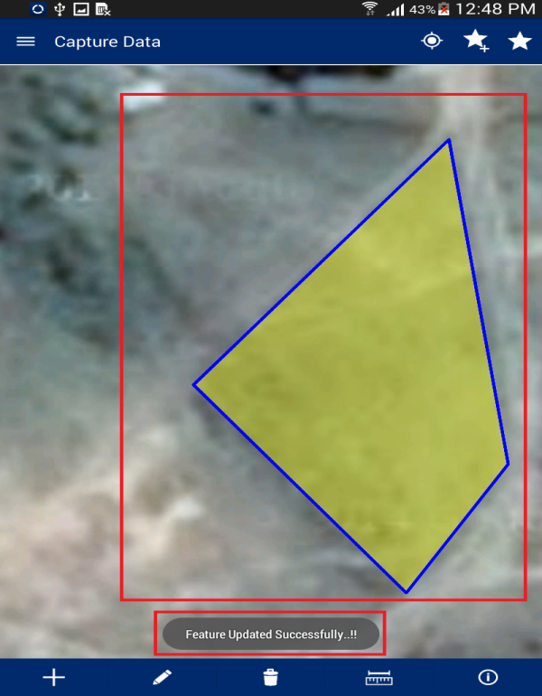Application will save updated spatial features and an acknowledgement message will display

**Note:** **In case feature is not visible, click on back arrow button on left hand top of screen. Click on ‘Capture Spatial’ data icon. Application will open up Layer Manager. Switch on the Captured Features layer.**

# 

# Delete Feature

This functionality allows the user to delete spatial data.

**Steps:**

1. 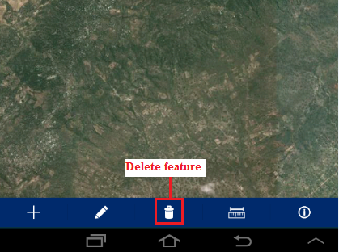Click on Delete icon
2. Click on the created spatial feature
3. The application will display a confirmation message to the user: “Are you sure you want to delete this feature?” with ‘Ok’ and ‘Cancel’ option
4. 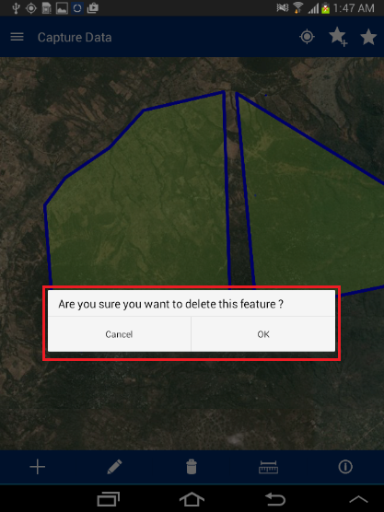Click on ‘Ok’ button
5. 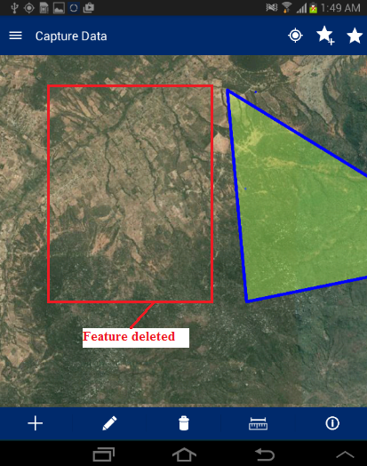Application will delete the selected feature and same will not be visible in the map

# Measure

This functionality allows the user to measure the area of any polygon, length of any line or the distance between two points on map.

**Steps:**

1. 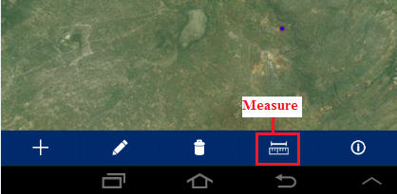Tap on ‘Measure’ option available on bottom of ‘Capture Data’ tool
2. ‘Select feature to measure’ dialogue will be displayed with following options:
   * + Calculate Distance
     + Calculate Area
     + Measure Polygon Area
     + Measure Line Length



## Calculate Distance

This functionality allows the user to calculate the distance between two or more subsequent points on the map.

**Steps:**

1. Tap on ‘Measure’ option available on top right
2. Select ‘Calculate distance’ option
3. Click on map to specify at least two points
4. Application will calculate distance and display it on top right of application
5. 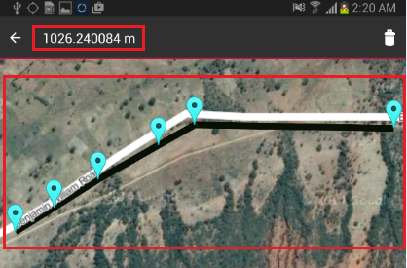

## Calculate Area

This functionality allows the user to calculate the area of a polygon by specifying it on map.

**Steps:**

1. Tap on ‘Measure’ option available on top right
2. Select ‘Calculate Area’ option
3. Click on map to specify at least three points
4. 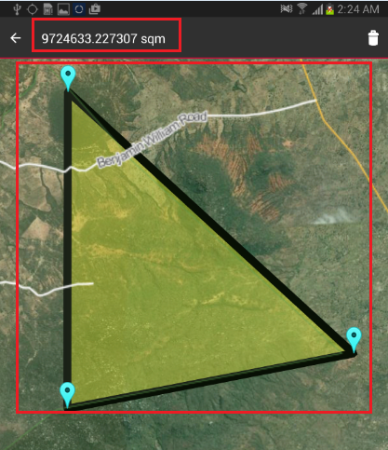Application will calculate Area and display it on top right of application

## Measure Polygon Area

This functionality allows the user to calculate the area of existing polygon feature by specifying it on the map.

**Steps:**

1. Tap on ‘Measure’ option available on top right
2. Select ‘Measure Polygon Area’ option
3. Click on existing polygon feature map
4. 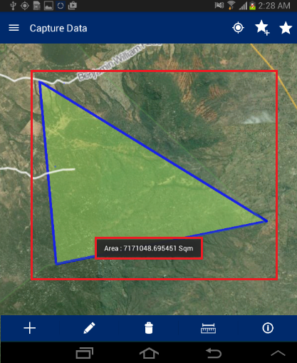Application will calculate Area and display it on the map only

## Measure Line Length

This functionality allows the user to calculate the length of an existing line feature by specifying it on the map.

**Steps:**

1. Tap on ‘Measure’ option available on top right
2. Select ‘Measure Line Length’ option
3. Click on existing line feature map
4. 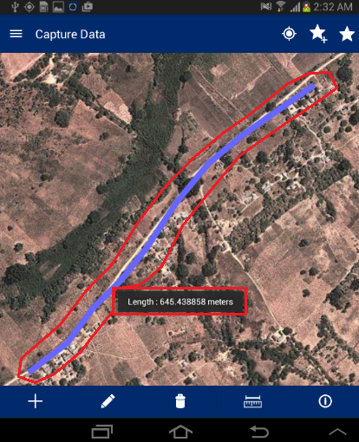The application will calculate length and display it on map only

# Map Info Tool

This functionality allows the user to view the attribute details of any spatial feature which is already created on map.

**Steps:**

1. Navigate to existing feature on map
2. Tap on ‘Map Info’ option available on bottom of Capture tool
3. Click on feature on map
4. 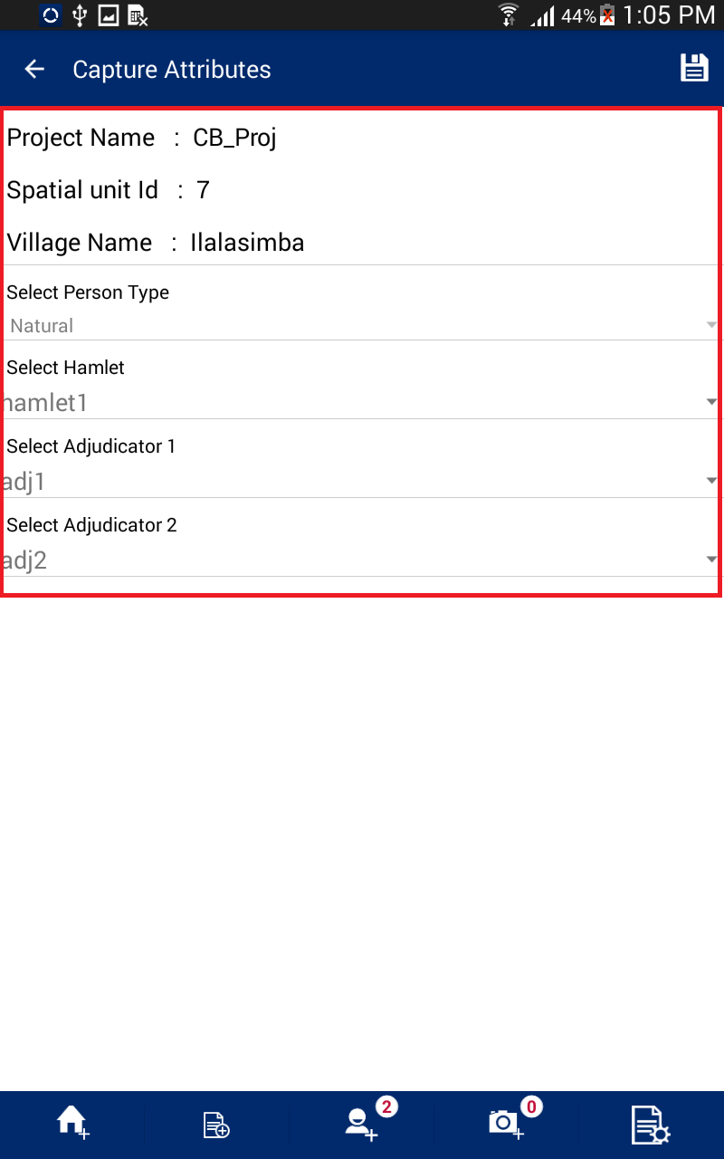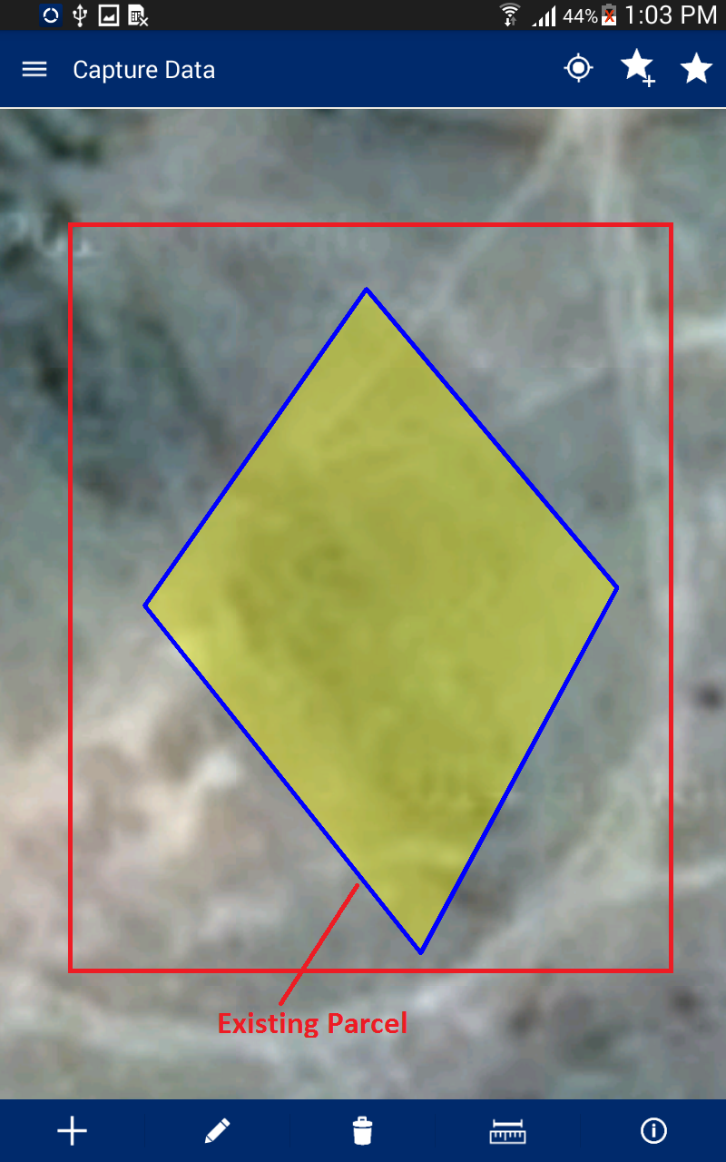Attribute details of specified feature will be displayed
5. Review Data

This functionality allows the user to view the data collected in the field for review and finalization. This also allows the user to Edit Special, Edit Attribute, Delete Entry or mark a parcel as Complete.

**Steps:**

1. 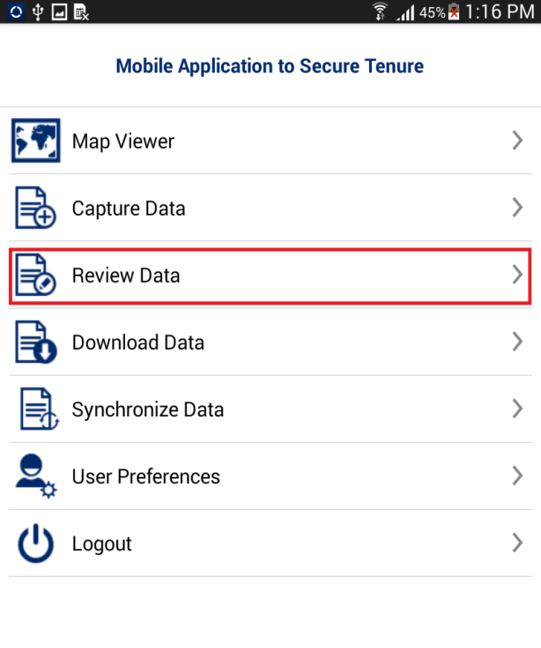Click on ‘Review Data‘ option available on Home page
2. ‘Review Data’ form will be displayed with following lists
   * + **Draft –** Parcels that are not marked as complete will be listed in ‘Draft’ list
     + **Completed –** Parcels that are marked as complete will be listed in ‘Completed’ list
     + **Synced –** Parcels that have been synced will be listed in ‘Synced’ list
     + 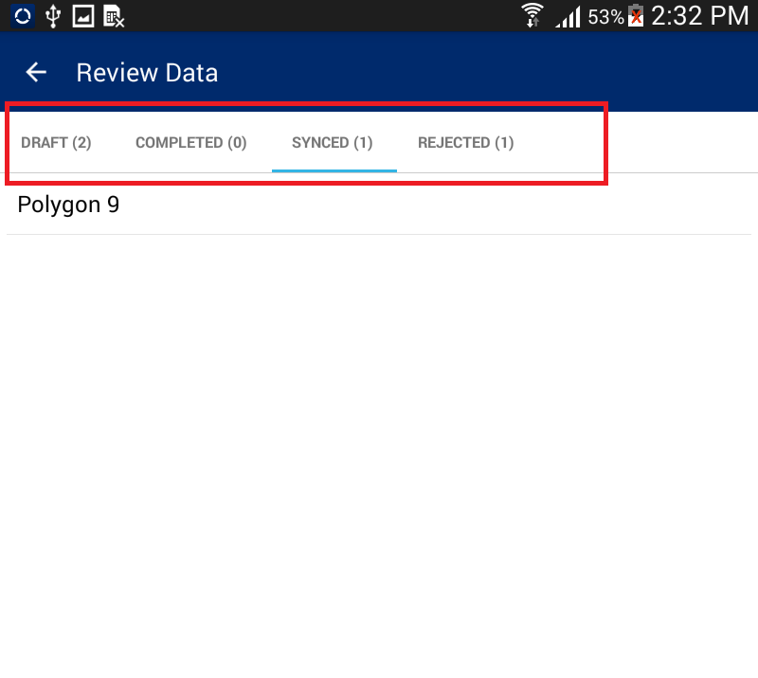**Rejected –** Parcels that are rejected from the back-end web application, will be listed in the ‘Rejected’ list

# Draft List

A parcel that is not marked as completed will be listed in ‘Draft’ list. The user can perform the following actions on parcels available in Draft List:

* + - Edit Special
    - Edit Attribute
    - Delete Entry
    - Mark as Complete

**Steps:**

1. Click on the ‘Action’ option available with the parcel record in the ‘Draft List’

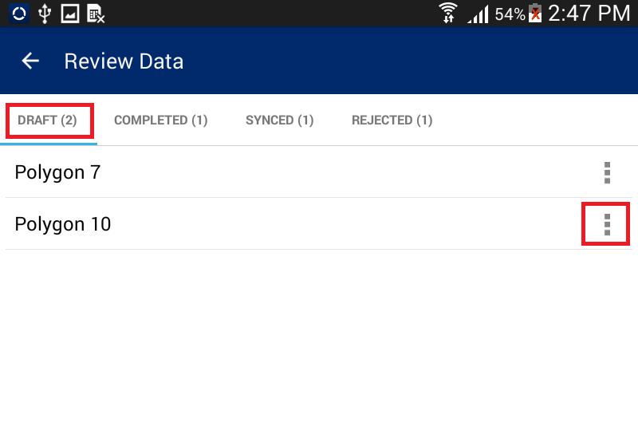

1. A list of available possible actions will be displayed

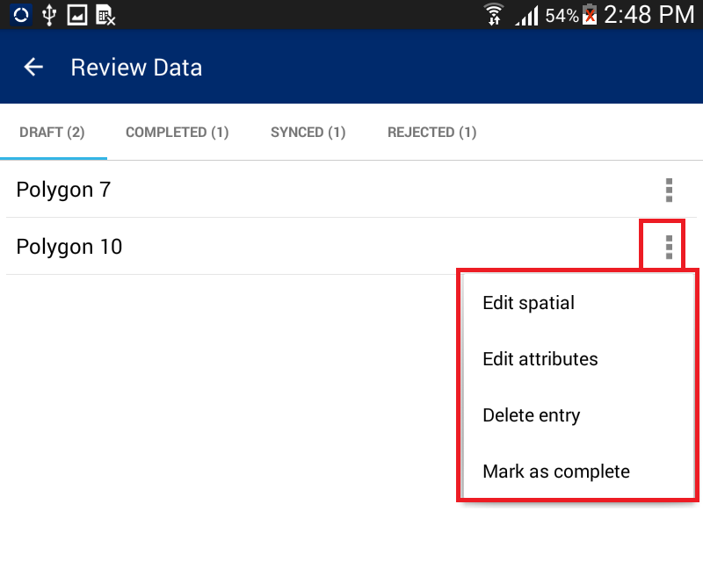

## Edit Spatial

This functionality allows the user to perform editing on spatial data.

**Steps:**

1. 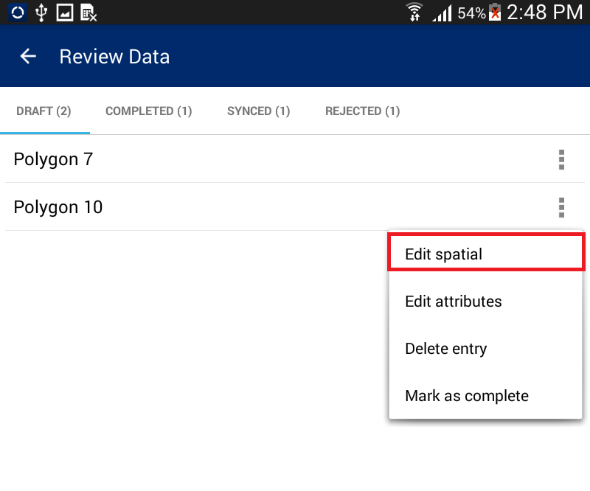Select the ‘Edit Spatial’ option
2. User will navigate to map and the corresponding feature will be available in edit mode.
3. 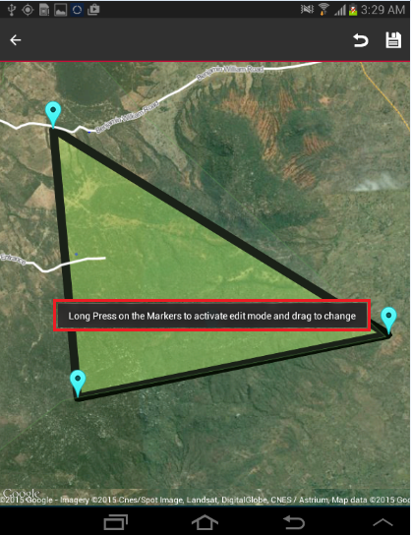Select node/vertices by long pressing the node/vertices and move the same.
4. Click on ‘Save’ option
5. Application will save updated spatial feature.

**Note: In case feature is not visible, click on back arrow button on left hand top of screen. Click on Capture Spatial data icon. Application will open up Layer Manager. Switch on Captured Features layer.**

## Edit Attribute

This functionality allows the user to edit attribute data for the spatial unit.

**Steps:**

1. Click on ‘Edit Attribute’ option

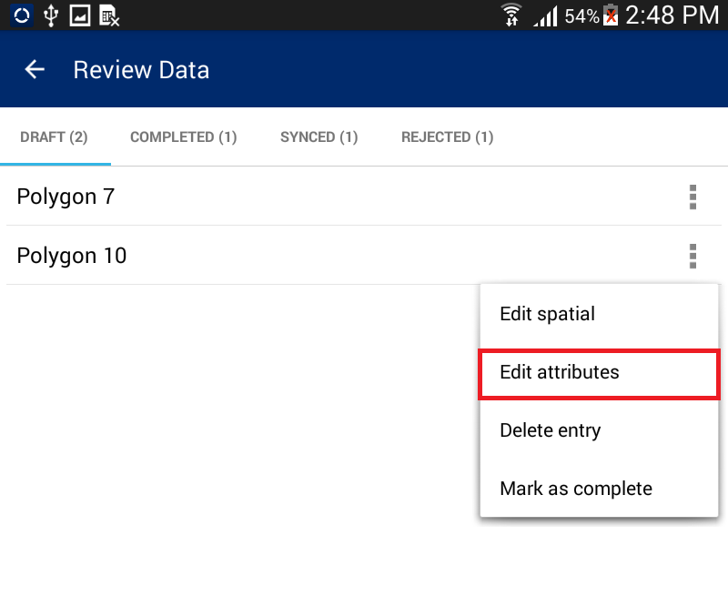

1. 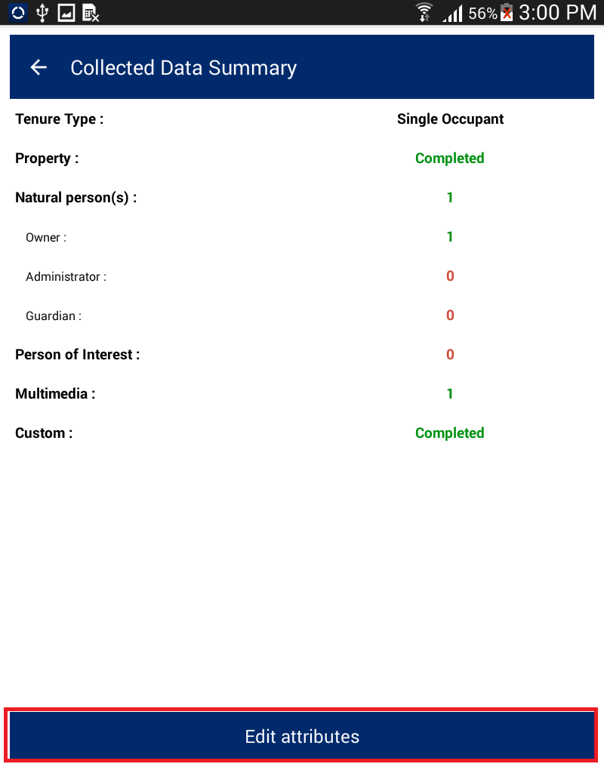User will navigate to ‘Collected Data Summary’ form. This will display the summarized details of the survey. There will be a button ‘Edit Attribute’
2. Click on ‘Edit Attribute’ button
3. User will navigate to ‘Capture Attribute’ form and attributes of corresponding feature will be available in edit mode
4. Edit required attributes
5. Click on ‘Save’ option
6. Application will save updated attribute details and an acknowledge message will be displayed

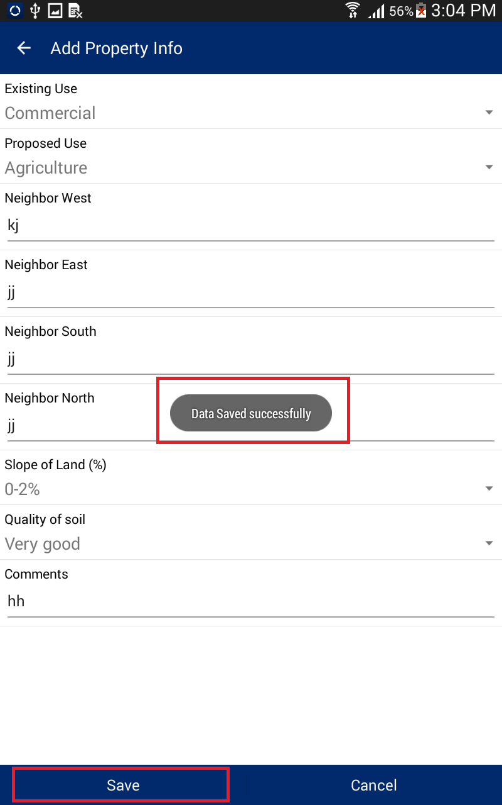

## Delete Entry

This functionality allows the user to delete a spatial unit along with all of its attribute data.

**Steps:**

1. Click on ‘Delete Entry’ option

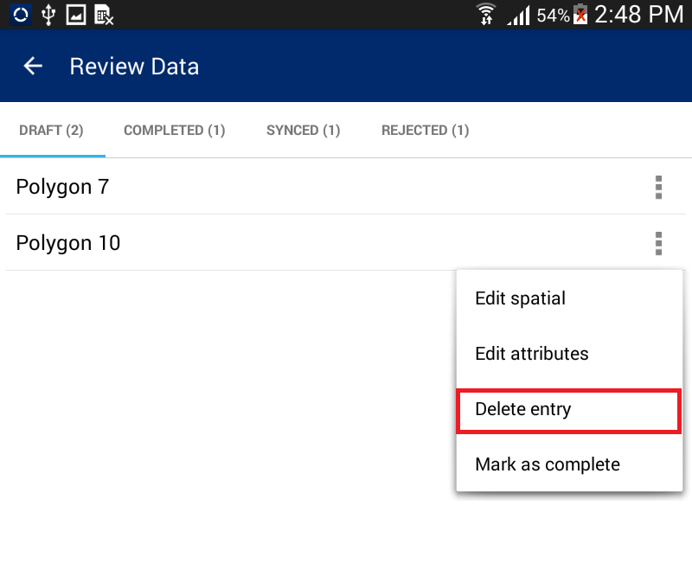

1. Application will display a confirmation message along with ‘Cancel’ and ‘OK’ button
2. 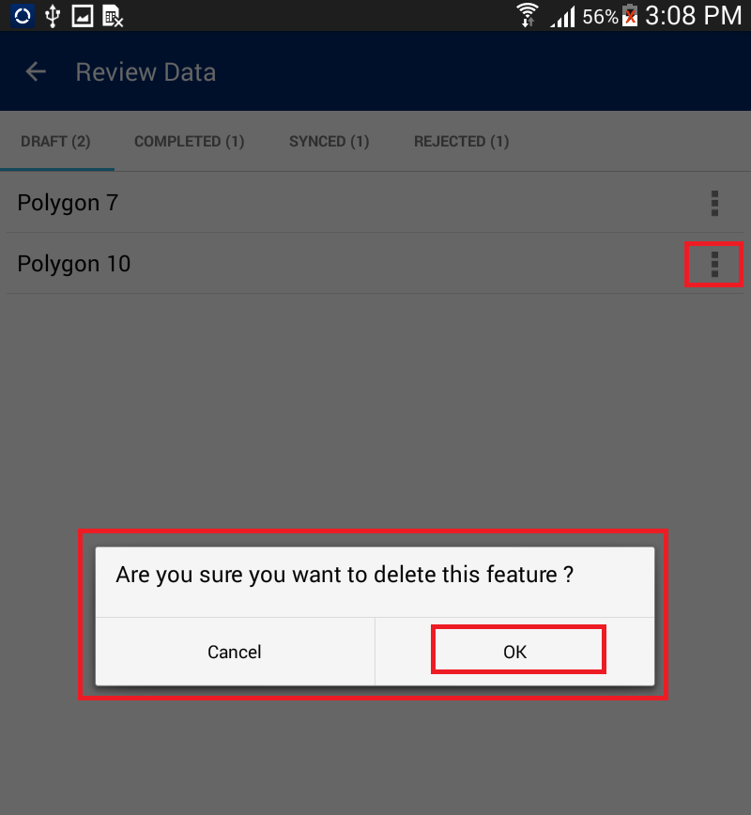Click on ‘OK’ button
3. Corresponding feature along with its attribute details will be deleted

## Mark as complete

This functionality allows the user to mark a parcel complete. Once a parcel is completed it can be synchronized.

**Steps:**

1. Click on ‘Mark as Complete’ option

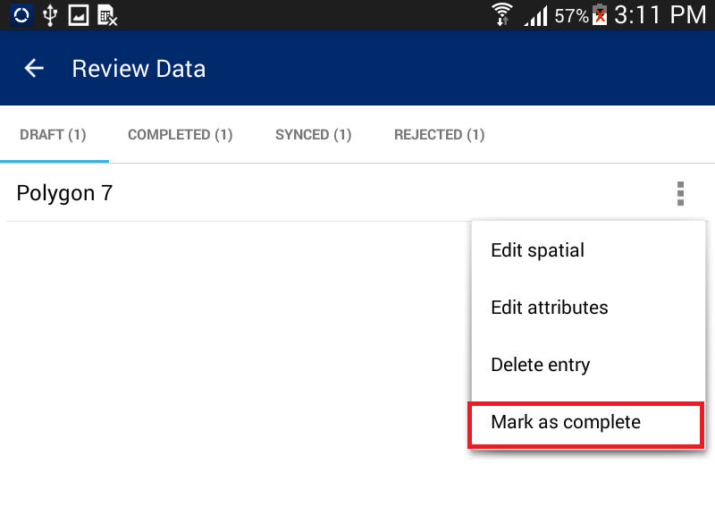

1. Application will display a confirmation message along with ‘Cancel’ and ‘OK’ button
2. Click on OK button

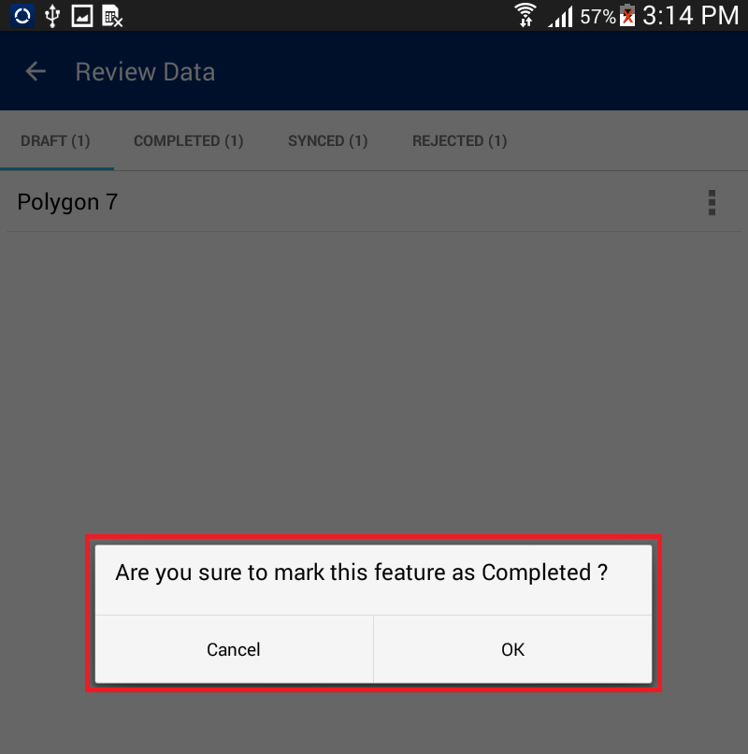Parcel will be completed. It will be removed from ‘Draft’ List and will become available in the ‘Completed’ List

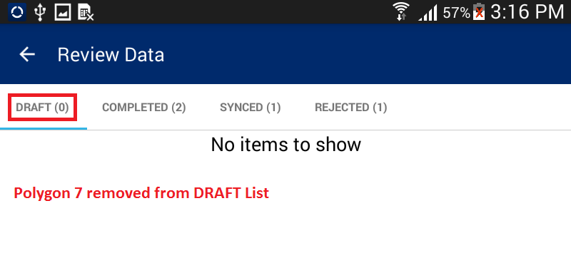

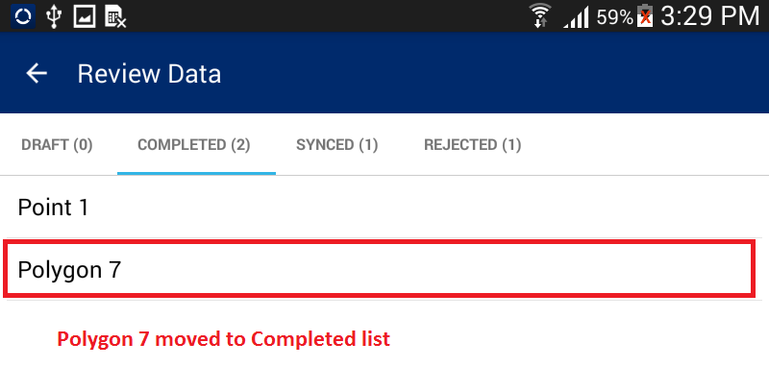

1. Download Data

This functionality allows the user to download configuration information and base data on the device. Top download data, mobile device should be in connected mode (i.e., internet should be available in device).

**Steps:**

1. Click on ‘Download Data’ option available in Home page
2. 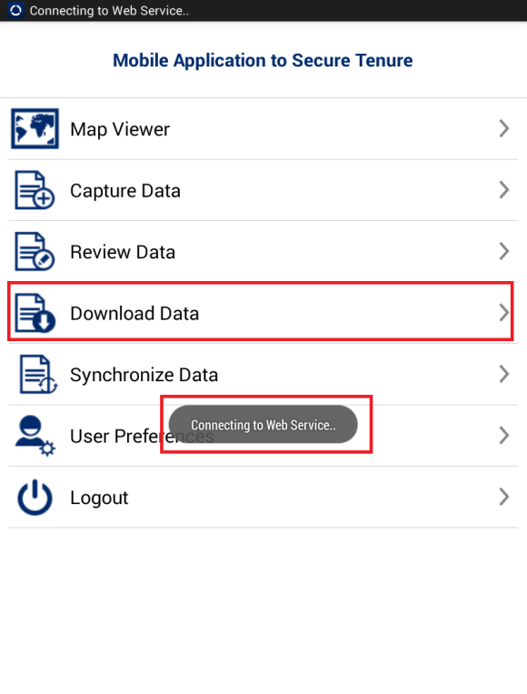Application will connect to the remote server and download required data
3. 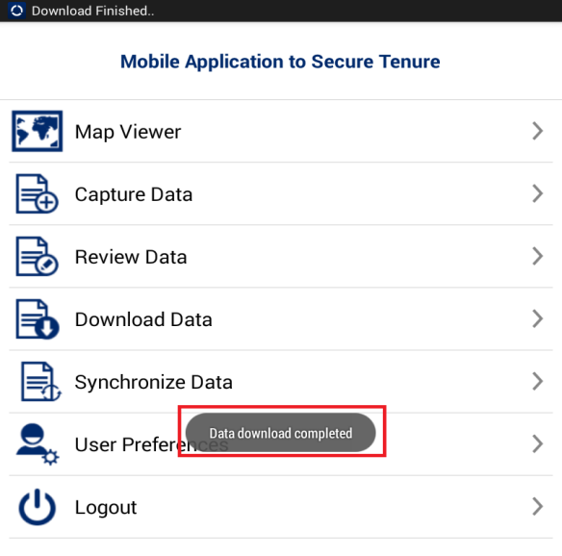Once Data Download is completed, an acknowledgement message will be displayed

1. Synchronize Data

This functionality allows the user to submit completed and verified data to the back-end cloud server.

**Steps:**

1. Click on the ‘Synchronize Data’ option available on the Home page
2. 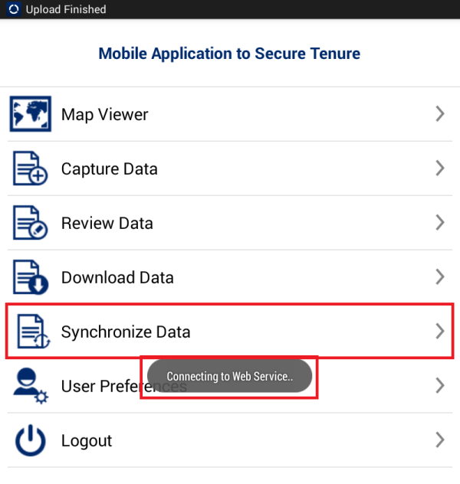Application will connect to the remote server to upload data
3. 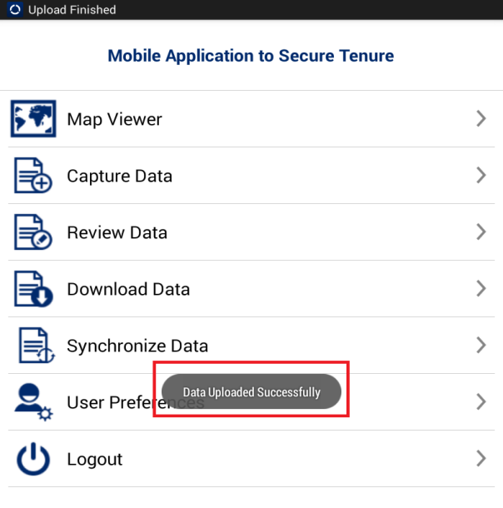Once Data Synchronization is completed, an acknowledgement message will be displayed
4. User Preferences

This functionality allows the user to change settings for the MAST mobile application. This functionality also allows the user to change default language, configure data collection tools, configure sync up and map display.

**Steps:**

1. 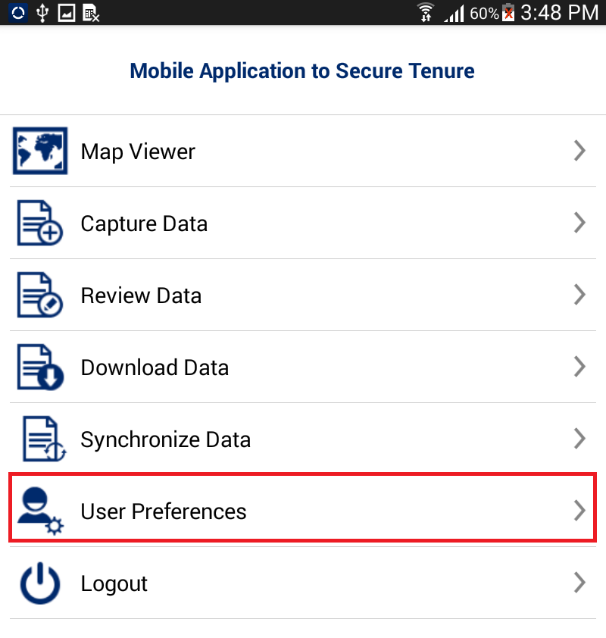Click on ‘User Preferences' option available on the Home page.
2. User Preferences for will be displayed with following options:
   * + Change Language
     + Configure Data Collection Tool
     + Configure Auto Sync
     + 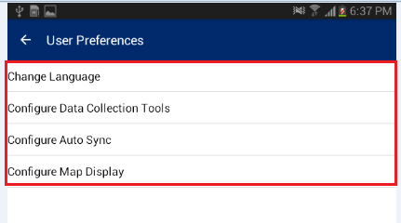Configure Map Display

# Change Language

This functionality allows the user to change to a preferred language for the mobile application.

**Steps:**

1. Click on ‘Change Language’ option
2. 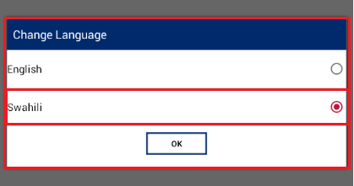Application will display ‘Change Language’ dialogue
3. Select desired language
4. 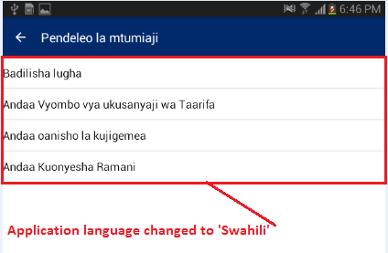Click on OK button, language of the MAST application will be changed

# Configure Data Collection Tool

This functionality allows the user to configure the spatial data collection tools.

**Steps:**

1. Click on ‘Configure Data Collection Tool’ option
2. ‘Configure Data Collection Tool’ dialogue box will be displayed with following options:
   * + Capture Point
     + Capture Line
     + Capture Polygon

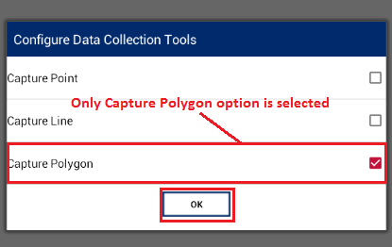

1. User selects appropriate options
2. Click on OK button
3. Navigate to ‘Capture Data’, and click on `Create Data’ tool
4. Application will show options to create only configured features

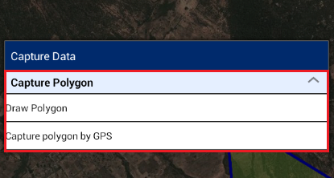

# Configure Auto Sync

This functionality allows the user to configure the sync up settings on the device. Users can configure sync up to be 'Auto Sync'. Auto Sync means that the data will be synced automatically to the back-end server whenever internet connectivity is available.

**Steps:**

1. Click on ‘Configure Auto Sync’ option
2. 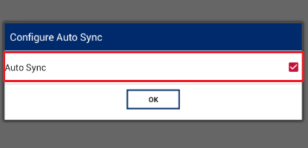‘Configure Auto Sync’ dialogue box will be displayed
3. Check ‘Auto Sync’ option, if user wishes to enable auto sync up
4. Click on OK button

# Configure Map Display

This functionality allows the user to configure the display properties of spatial units on the map viewer. The user can configure the color of point, line, and polygon features of vector data layer.

**Steps:**

1. Click on ‘Configure Map Display’ option
2. ‘Configure Map Display’ form will be displayed with following options.
   * + Point
     + Line
     + Polygon

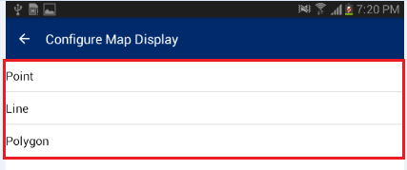

## Point

This functionality allows the user to configure the color of the ‘Point’ feature.

**Steps:**

1. Click on Point option
2. Choose Color dialogue box will be displayed
3. Choose desired color
4. Click on ‘OK’ button
5. Navigate to the Map viewer, spatial units of Point type will be displayed as per display settings configured by user

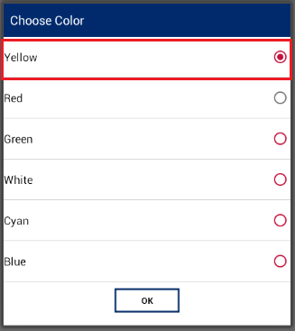

## Line

This functionality allows the user to configure the color of the ‘Line’ feature.

**Steps:**

1. Click on Line option
2. Choose Color dialogue box will be displayed
3. 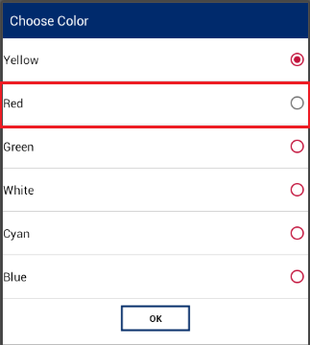Choose desired color
4. Click on ‘OK’ button
5. Navigate to the Map viewer, spatial units of Line type will be displayed as per display settings configured by user

## Polygon

This functionality allows the user to configure the color of the ‘Polygon’ feature.

**Steps:**

1. Click on Polygon option
2. Choose Color dialogue box will be displayed
3. 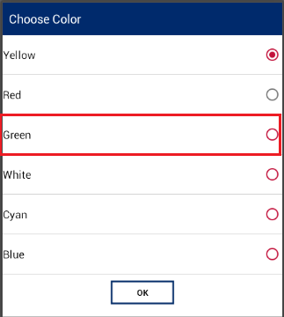Choose desired color
4. Click on ‘OK’ button
5. Navigate to the Map viewer, spatial units of Polygon type will be displayed as per display settings configured by user
6. Logout

This functionality allows the user to logout from the application. When the user clicks on the logout option, if any of the completed parcel is pending for sync up, the application displays a notification message.

**Steps:**

1. 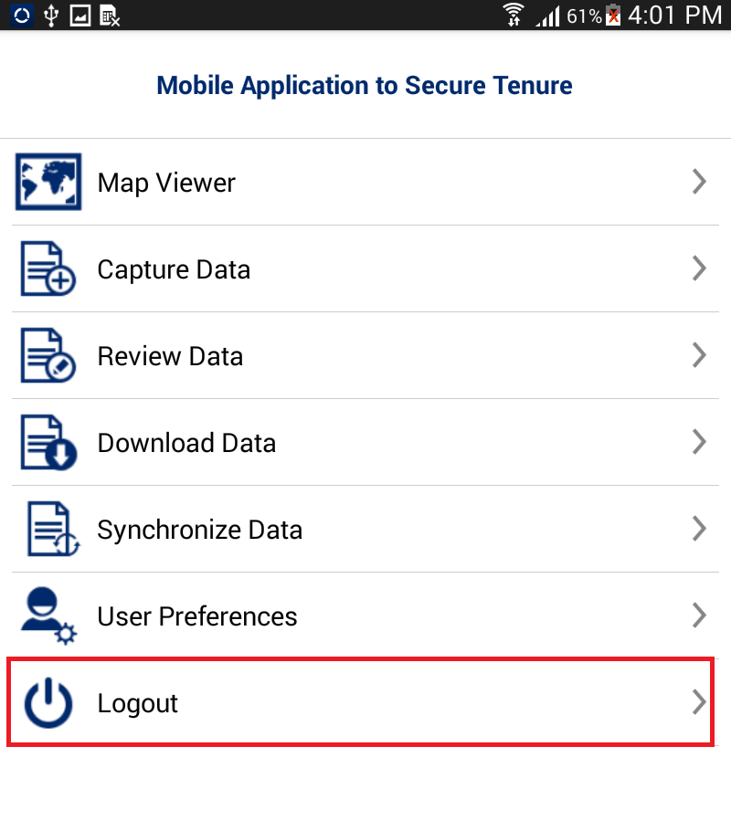Click on ‘Logout’ option available on Home page
2. If any of the completed parcel is pending for sync up, the application displays a Warning message

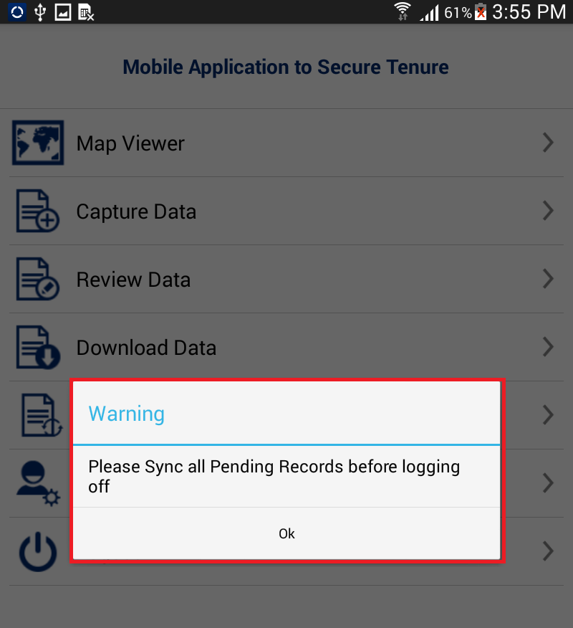

1. If there is no pending parcel for sync up, the application displays a Warning message

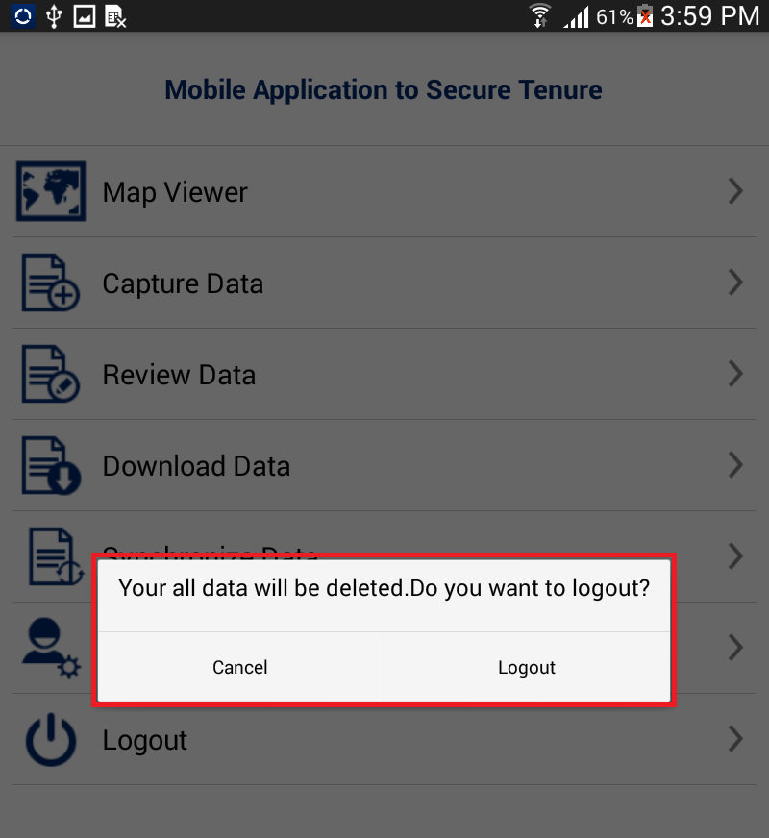

1. Click on Logout button. The user will be logged out from the application.

U.S. Agency for International Development

1300 Pennsylvania Avenue, NW

Washington, DC 20523

Tel: (202) 712-0000

Fax: (202) 216-3524

www.usaid.gov